|  |  |
| --- | --- |
| HealthIT.gov, National Learning Consortium (NLC), Advancing America's Health Care | **FACT SHEET**  **December 2012** |

# Providing Patients in Ambulatory Care Settings with a Clinical Summary of the Office Visit

A core meaningful use requirement for patient and family engagement is to provide patients with a clinical summary of the office visit. This summary supports continuity of patient care by providing patients and their families with relevant and actionable information. Also, it can reduce calls and extra work for you.

It is designed to be given to patients at the end of an office medical visit as a summary of what happened during the visit and to provide information and instructions to guide their next healthcare steps. An office visit is any billable visit, including concurrent care or transfer of care visits, consultant visits, or prolonged physician service without direct (face-to-face) patient contact, such as telehealth.

Although the clinical summary was designed to be provided to the patient at the conclusion of the office visit, Stage 1 of meaningful use requires it to be provided to the patient within 3 days. Stage 2 requires it to be provided to the patient within 1 business day. You may deliver the summary through an electronic health record (EHR) patient portal, secure e-mail, electronic media (such as a CD or USB flash drive), or as a printed copy. If the patient requests it, the healthcare provider *must* provide a printed copy.

*A photograph looking over the shoulder of the patient  as they look at the Patient Clinical Summary and the doctor looks on. *

## Importance of the Printed Copy

*During recent conversations with a large integrated health system about “going green” and reducing the use of paper in their facilities, the consensus was that the clinical summary is the one paper document they will definitely continue using, as it is an invaluable communication tool.*

## Information in the Clinical Summary

The clinical summary provides an opportunity for the clinician to verbally review the information with the patient, reinforce the importance of the summary itself, and explain key pieces of information, such as special medication instructions or necessary follow-up care. Don’t underestimate the importance of reviewing the summary with patients, as they are more likely to see the value of the summary if it is acknowledged and addressed during the office visit. Core information in the clinical summary includes:

* Patient name
* Provider name
* Date and location of visit
* Reason(s) for visit
* Vitals (temperature, blood pressure, height, weight, BMI, exercise status in minutes/week)
* Smoking Status**
* Demographic Information**
* Problem list/current conditions*
* Medication list*
* Medication allergies*
* Diagnostic test/lab results*
* Patient instructions
* Recommended Patient Decision Aids**
* Care Plan Field**

*\*Required for Stage 1 of Meaningful Use*

*\*\*Required for Stage 2 of Meaningful Use*

Additional information in the summary may include:

* Referrals
* Problem history
* Topics covered during the visit
* Immunizations or medications administered during visit
* When next appointment is recommended
* Other appointments/ testing that patient needs to
* schedule
* Appointments/testing already scheduled
* Medication instructions
* Personalized instructions/ notes
* Links to (or copies of) relevant educational information
* Care gaps
* Preventive screenings due
* Personalized message/ closing

Healthcare providers may withhold certain information if it is believed that such information would cause substantial harm to the patient or another individual.

## Tips for a Successful Clinical Summary

* Use formatting, such as bold type, to highlight important health information.
* Highlight categories or major sections of information, such as health reminders, referrals, procedures, and medications.
* Display actionable information as well as the clinic phone number prominently and clearly.
* Use plain language and define or explain terms that may be difficult for some patients to understand.
* Keep the length to one or two pages.
* Consider the needs of the patient population when deciding what information to include. If possible, involve patients in the development and design to help ensure the desired impact.
* Tailor the content to meet patient needs and preferences. Also, ask for patient feedback during rollout to help ensure that the information/messages are easily understood.

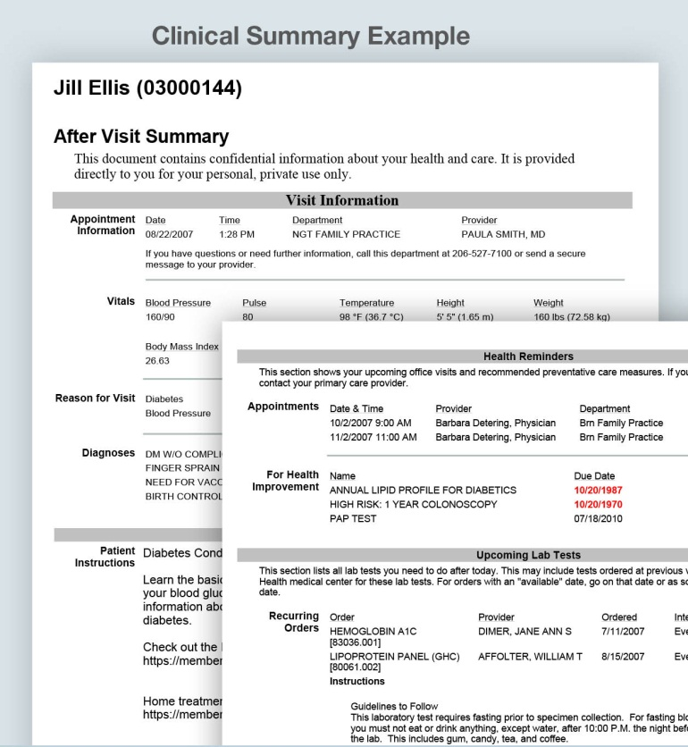*

Information included in this example may appear to contain personally identifiable data; however, this data is representational only.   
No personally identifiable information (PII) or protected health information (PHI) is contained here.