Transition of Care to a New Provider
HIE Scenario, Workflow and Specifications

Provided By:
The National Learning Consortium (NLC)

Developed By:
Office of the National Coordinator for Health IT (ONC)
Office of Science and Technology (OST)
The material in this document was developed by Regional Extension Center staff in the performance of technical support and EHR implementation. The information in this document is not intended to serve as legal advice nor should it substitute for legal counsel. Users are encouraged to seek additional detailed technical guidance to supplement the information contained within. The REC staff developed these materials based on the technology and law that were in place at the time this document was developed. Therefore, advances in technology and/or changes to the law subsequent to that date may not have been incorporated into this material.
May 31, 2012 • Version 1.0

National Learning Consortium
The National Learning Consortium (NLC) is a virtual and evolving body of knowledge and tools designed to support healthcare providers and health IT professionals working towards the implementation, adoption and meaningful use of certified EHR systems.
The NLC represents the collective EHR implementation experiences and knowledge gained directly from the field of ONC’s outreach programs (REC, Beacon, State HIE) and through the Health Information Technology Research Center (HITRC) Communities of Practice (CoPs).
The following resource is an example of a tool used in the field today that is recommended by “boots-on-the-ground” professionals for use by others who have made the commitment to implement or upgrade to certified EHR systems.
Description & Instructions
This resource is intended to aid providers and health IT implementers in understanding health information exchange (HIE) solutions related to the Meaningful Use Menu Measure 8 – Transition of Care.
This scenario provides a practical example of how the contents of the Nationwide Health Information Network (NwHIN) portfolio can be used to achieve meaningful electronic exchange of health information. This is part of a series of HIE scenarios intended to provide a straightforward view into the standards, services and policies behind HIE solutions.
Each document in the HIE scenarios series describes an everyday situation where patient care is improved through information exchange between health care professionals.
The scenario is presented through a narrative description of events and a corresponding graphic, followed by a detailed description of the workflow steps involved. The resource concludes with an inventory of the key specifications and resources necessary to implement the information exchange described.
Other scenarios and their related specifications can be found on the S&I Framework Repository at: http://www.siframework.org/. Additional questions may be sent via email to: info@siframework.org.

Table of Contents
1 Transition of Care to a New Provider 1
1.1 Common workflow steps for this scenario 2
1.2 NwHIN 1.0 specifications and resources recommended for this scenario 2

Transition of Care to a New Provider
An emergency department physician sends a continuity of care document for a patient to her primary care physician: 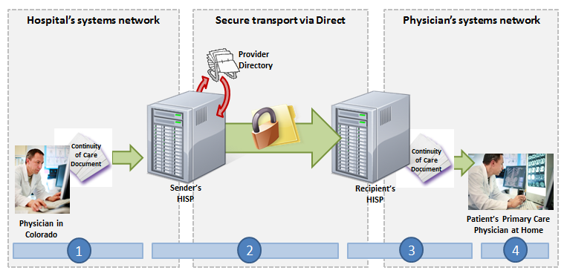
A patient on vacation in Colorado visits an emergency department (ED) physician after injuring her arm in a biking accident. The ED physician orders x-rays and determines that the patient has fractured her arm. He sets the arm in a cast, prescribes pain medication, and requests that the patient visit her primary care physician in two weeks for a follow-up visit. Ahead of the follow-up visit, the ED physician electronically sends a Continuity of Care Document (CCD) to the patient’s primary care physician.

Meaningful Use Stage 1 Objectives related to transitions of care: The EP, eligible hospital or CAH who transitions or refers their patient to another setting of care or provider of care should provide a summary care record for each transition of care or referral. (Meaningful Use Menu Set Measure 8 for EPs, Meaningful Use Menu Set Measure 7 for EH/CAHs)

Common workflow steps for this scenario
- The ED physician extracts a Continuity of Care Document (CCD) for the patient from his EHR, which has been properly formatted according to the HL7 CDA Release 2 CCD standard using ICD-9-CM, Logistical Observation Identifiers names and Codes (LOINC) 2.38, RxNorm, and Systemized Nomenclature of Medical--Clinical Terms (SNOMED-CT). He then authors a Direct message and attaches the CCD. In order to select the patient’s primary care physician as the recipient, the ED physician accesses a search dialogue in the HISP's user interface, which queries a Provider Directory (adhering to the Certificate Discovery for Direct specification) for the right Direct address.
- When the ED physician sends the message, it passes through the hospital’s Health Information Service Provider (HISP), a contracted brokering agent responsible for the management of security and transport for directed exchange. As it passes through the HISP, the message is encrypted using the x.509 Certificate associated with the primary care physician, and is delivered to the primary care physician’s Direct address in accordance with the Applicability Statement for Secure Health Transport.
- The primary care physician’s HISP decrypts the message and routes it to the primary care physician.
- The primary care physician uses the HISP’s user interface to access the CCD in his Direct inbox.

NwHIN 1.0 specifications and resources recommended for this scenario
Specifications | Resources
Content Structure  Guidance that specifies how to structure health information to ensure proper exchange | - HL7 CDA Release 2 CCD
Vocabulary & Code Sets  Specifications that identify common naming conventions necessary for proper health information exchange | - ICD-9-CM  - Logistical Observation Identifiers names and Codes (LOINC) 2.38  - RxNorm  - Systematized Nomenclature of Medicine--Clinical Terms (SNOMED-CT)
Transport and Security  Mechanisms and processes that safely exchange health information over the Internet | - Certificate Discovery using Domain Name System (DNS) and Lightweight Directory Access Protocol (LDAP)  - Applicability Statement for Secure Health Transport  - x.509 for Certificates

