Submitting Immunization Data to Public Health
HIE Scenario, Workflow and Specifications

Provided By:
The National Learning Consortium (NLC)

Developed By:
Office of the National Coordinator for Health IT (ONC)
Office of Science and Technology (OST)
The material in this document was developed by Regional Extension Center staff in the performance of technical support and EHR implementation. The information in this document is not intended to serve as legal advice nor should it substitute for legal counsel. Users are encouraged to seek additional detailed technical guidance to supplement the information contained within. The REC staff developed these materials based on the technology and law that were in place at the time this document was developed. Therefore, advances in technology and/or changes to the law subsequent to that date may not have been incorporated into this material.
May 31, 2012 • Version 1.0

National Learning Consortium
The National Learning Consortium (NLC) is a virtual and evolving body of knowledge and tools designed to support healthcare providers and health IT professionals working towards the implementation, adoption and meaningful use of certified EHR systems.
The NLC represents the collective EHR implementation experiences and knowledge gained directly from the field of ONC’s outreach programs (REC, Beacon, State HIE) and through the Health Information Technology Research Center (HITRC) Communities of Practice (CoPs).
The following resource is an example of a tool used in the field today that is recommended by “boots-on-the-ground” professionals for use by others who have made the commitment to implement or upgrade to certified EHR systems.
Description & Instructions
This resource is intended to aid providers and health IT implementers in understanding health information exchange (HIE) solutions related to the Meaningful Use Menu Measure 9 – Immunization Registries Data Submission.
This scenario provides a practical example of how the contents of the Nationwide Health Information Network (NwHIN) portfolio can be used to achieve meaningful electronic exchange of health information. This is part of a series of HIE scenarios intended to provide a straightforward view into the standards, services and policies behind HIE solutions.
Each document in the HIE scenarios series describes an everyday situation where patient care is improved through information exchange between health care professionals.
The scenario is presented through a narrative description of events and a corresponding graphic, followed by a detailed description of the workflow steps involved. The resource concludes with an inventory of the key specifications and resources necessary to implement the information exchange described.
Other scenarios and their related specifications can be found on the S&I Framework Repository at: http://www.siframework.org/. Additional questions may be sent via email to: info@siframework.org.

Table of Contents
1 Submitting Immunization Data to Public Health 1
1.1 Common workflow steps for this scenario 2
1.2 NwHIN 1.0 specifications and resources recommended for this scenario 2

Submitting Immunization Data to Public Health
A physician sends a patient’s immunization record to the state’s immunization information system: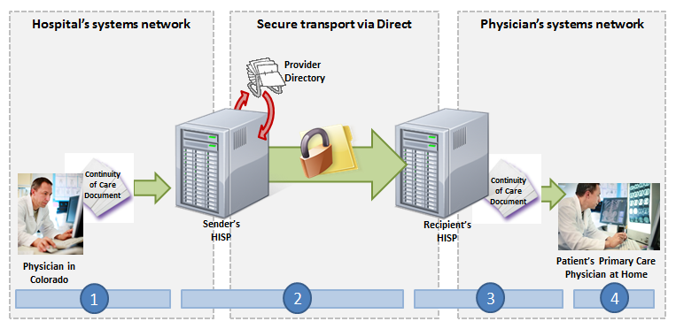
Parents of a one-year old take their child to his primary care physician to be immunized in accordance with Centers for Disease Control and Prevention (CDC) recommendations. Upon completion of the varicella and MMR vaccines, the primary care physician updates the patient’s electronic health record (EHR) and accesses the state’s Immunization Information System (IIS) interface from within the EHR system. The physician then sends the immunization record to the IIS.

Meaningful Use Stage 1 Objectives related to immunization registries: Capability to submit electronic data to immunization registries or immunization information systems except where prohibited, and in accordance with applicable law and practice. (Meaningful Use Menu Set Measure 9 for EPs, Meaningful Use Menu Set Measure 8 for EH/CAHs)

Common workflow steps for this scenario
- The primary care physician enters the immunization data into his EHR and then accesses the state’s IIS through the EHR, which is possible because the physician practice has signed a user agreement with the state, and the EHR vendor supports HL7 v.2.5.1 and has a Secure File Transfer Protocol (SFTP) interface.
- The EHR automatically uploads the physician’s file, which has been properly formatted according to HL7 v.2.5.1 Implementation Guide for Immunization Messaging, using CVX codes, into the state’s SFTP system. The state’s system processes and stores the immunization record in the state’s immunization registry database.
- The IIS sends an acknowledgement message via email to the primary care physician’s EHR indicating that the immunization record was successfully stored.

NwHIN 1.0 specifications and resources recommended for this scenario
Specifications | Resources
Content Structure  Guidance that specifies how to structure health information to ensure proper exchange | - HL7 v. 2.5.1 Implementation Guide for Immunization Messaging, Release 1.3
Vocabulary & Code Sets  Specifications that identify common naming conventions necessary for proper health information exchange | - CVX Code Set: August 15, 2011 version

