Lab Results Delivery
HIE Scenario, Workflow and Specifications

Provided By:
The National Learning Consortium (NLC)

Developed By:
Office of the National Coordinator for Health IT (ONC)
Office of Science and Technology (OST)
The material in this document was developed by Regional Extension Center staff in the performance of technical support and EHR implementation. The information in this document is not intended to serve as legal advice nor should it substitute for legal counsel. Users are encouraged to seek additional detailed technical guidance to supplement the information contained within. The REC staff developed these materials based on the technology and law that were in place at the time this document was developed. Therefore, advances in technology and/or changes to the law subsequent to that date may not have been incorporated into this material.
May 31, 2012 • Version 1.0

National Learning Consortium
The National Learning Consortium (NLC) is a virtual and evolving body of knowledge and tools designed to support healthcare providers and health IT professionals working towards the implementation, adoption and meaningful use of certified EHR systems.
The NLC represents the collective EHR implementation experiences and knowledge gained directly from the field of ONC’s outreach programs (REC, Beacon, State HIE) and through the Health Information Technology Research Center (HITRC) Communities of Practice (CoPs).
The following resource is an example of a tool used in the field today that is recommended by “boots-on-the-ground” professionals for use by others who have made the commitment to implement or upgrade to certified EHR systems.
Description & Instructions
This resource is intended to aid providers and health IT implementers in understanding health information exchange (HIE) solutions related to the Meaningful Use Menu Measure 2 – Clinical Lab Results.
This scenario provides a practical example of how the contents of the Nationwide Health Information Network (NwHIN) portfolio can be used to achieve meaningful electronic exchange of health information. This is part of a series of HIE scenarios intended to provide a straightforward view into the standards, services and policies behind HIE solutions.
Each document in the HIE scenarios series describes an everyday situation where patient care is improved through information exchange between health care professionals.
The scenario is presented through a narrative description of events and a corresponding graphic, followed by a detailed description of the workflow steps involved. The resource concludes with an inventory of the key specifications and resources necessary to implement the information exchange described.
Other scenarios and their related specifications can be found on the S&I Framework Repository at: http://www.siframework.org/. Additional questions may be sent via email to: info@siframework.org.

Table of Contents
1 Delivering Lab Results 1
1.1 Common workflow steps for this scenario 2
1.2 NwHIN 1.0 specifications and resources recommended for this scenario 2

Delivering Lab Results
A laboratory sends a patient’s lab results to the ordering physician:
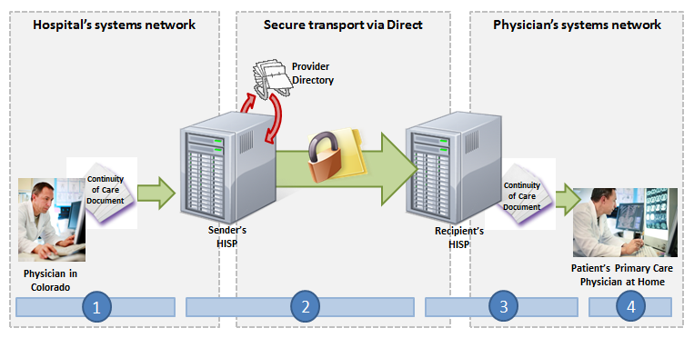
A patient visits his primary care physician for a routine visit. The primary care physician determines that lab work should be performed, so the patient schedules an appointment with a local reference lab. Once the lab tests have been completed, the reference lab electronically delivers the lab results to the primary care physician.
Meaningful Use Stage 1 Objectives related to lab results: Incorporate clinical lab-test results into certified EHR technology as structured data. (Meaningful Use Menu Set Measure 2 for EPs, Meaningful Use Menu Set Measure 3 for EH/CAHs)

Common workflow steps for this scenario
- A technician at the reference lab extracts the patient’s lab results report, which has been properly formatted according to the HL7 v.2.5.1 Laboratory Results Interface Implementation Guide, including using the Logistical Observation Identifiers names and Codes (LOINC) 2.38 vocabulary and RELMA 5.5. The technician then authors a Direct message and attaches the lab results report. In order to select the primary care physician as the recipient, the user accesses a search dialogue in the HISP's user interface, which queries a Provider Directory (adhering to the Certificate Discovery for Direct specification) for the right Direct address.
- The laboratory’s HISP, a contracted brokering agent responsible for the management of security and transport for directed exchange, retrieves the physician’s digital certificate from the Provider Directory. The laboratory’s HISP uses this certificate to encrypt the message and sends it to the ordering physician’s HISP in accordance with the Applicability Statement for Secure Health Transport, which uses x.509 for certificates.
- The ordering physician’s HISP decrypts the message and routes it to the ordering physician.
- The ordering physician uses the HISP’s user interface to access the lab report in his Direct inbox.

NwHIN 1.0 specifications and resources recommended for this scenario
Specifications | Resources
Content Structure  Guidance that specifies how to structure health information to ensure proper exchange | - HL7 CDA Release 2 CCD
Vocabulary & Code Sets  Specifications that identify common naming conventions necessary for proper health information exchange | - Logistical Observation Identifiers names and Codes (LOINC) 2.38  - RELMA 5.5
Transport and Security  Mechanisms and processes that safely exchange health information over the Internet | - Certificate Discovery for Direct  - Applicability Statement for Secure Health Transport  - x.509 for Certificates

