Checklist for Capability to Exchange Key Clinical Information
Checklist
Provided By:
The National Learning Consortium (NLC)

Developed By:
Health Information Technology Research Center (HITRC)

The material in this document was developed by Regional Extension Center staff in the performance of technical support and EHR implementation. The information in this document is not intended to serve as legal advice nor should it substitute for legal counsel. Users are encouraged to seek additional detailed technical guidance to supplement the information contained within. The REC staff developed these materials based on the technology and law that were in place at the time this document was developed. Therefore, advances in technology and/or changes to the law subsequent to that date may not have been incorporated into this material.

National Learning Consortium
The National Learning Consortium (NLC) is a virtual and evolving body of knowledge and tools designed to support healthcare providers and health IT professionals working towards the implementation, adoption and meaningful use of certified EHR systems.
The NLC represents the collective EHR implementation experiences and knowledge gained directly from the field of ONC’s outreach programs (REC, Beacon, State HIE) and through the Health Information Technology Research Center (HITRC) Communities of Practice (CoPs).
The following resource is an example of a tool used in the field today that is recommended by “boots-on-the-ground” professionals for use by others who have made the commitment to implement or upgrade to certified EHR systems.
Description & Instructions
The Exchanging Key Clinical Information checklist is designed for Eligible Professionals (EPs) practicing in a physician office or clinic setting. This checklist helps EPs prepare for the electronic exchange of key clinical information with other care providers and/or patient authorized entities. This checklist is a practical guide to outline options EPs may use for exchanging key clinical information under stage 1 Meaningful Use requirements, to achieve Core Objective 14 – Electronic Exchange of Clinical Information.
This checklist includes the steps to test the capability to exchange key clinical information, perform the test, document test completion, and test EP’s ability to receive and display a Continuity of Care Document/Continuity of Care Record (CCD/CCR).

Table of Contents
1 Checklist for Capability to Exchange Key Clinical Information 1
1.1 Formats 1
1.2 Transmission Methods 1
1.3 Testing partner 1
1.4 Documentation 2
2 Checklist for Stage 1 Meaningful Use Core Objective 14 3
3 Checklist for Receiving and Displaying CCD/CCR Information 5
4 Sample Documentation Form for Exchanging Key Clinical Information 6
5 Resources 7

List of Exhibits
Exhibit 1 Continuity of Care Document 1
Exhibit 2 Prepare to Test Capability to Exchange Key Clinical Information 3
Exhibit 3 Perform the Test 4
Exhibit 4 Document Completion of the Test 4
Exhibit 5 Test to Receive and Display a CCD/CCR 5
Exhibit 6 Resources 7

Checklist for Capability to Exchange Key Clinical Information
The eligible professional must perform a test of a certified Electronic Health Record (EHR) capacity to electronically exchange key clinical information with a different provider organization.
Here is how the objective is stated: Capability to exchange key clinical information (for example, problem list, medication list, medication allergies, diagnostic test results) among providers of care and patient authorized entities.
Exhibit 1 Continuity of Care Document

Formats
All certified EHRs can generate and receive a Continuity of Care Document (CCD) or Continuity of Care Record (CCR), standard formats for exchanging key clinical information. A sample CCD is shown at right. EHRs exchange an encoded version of the CCD. The MU test maybe conducted with hypothetical patient data as displayed in the sample CCD.
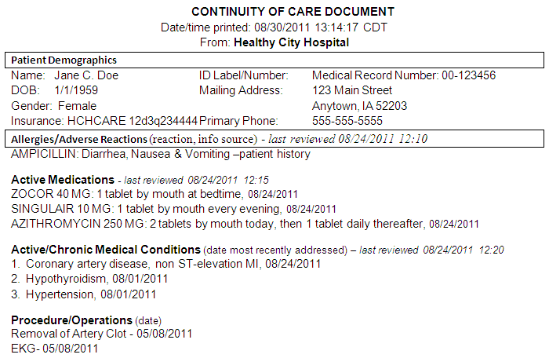
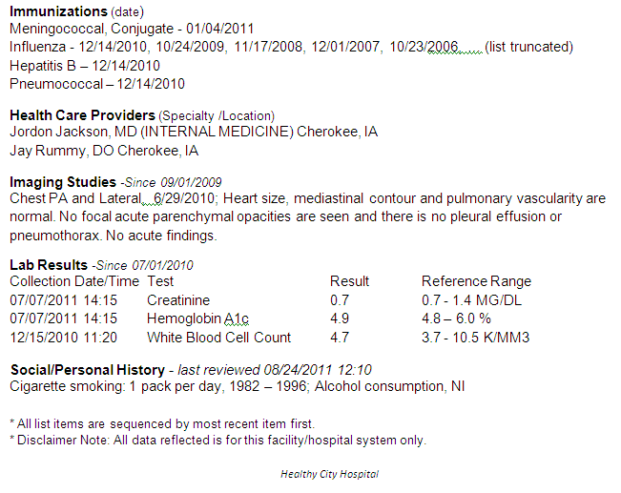

Transmission Methods
Acceptable transmission methods include, but are not limited to:
- Secure email (encrypted)
- Point-to-point interfaces
- Secure Web portals
- Batch transfer over secure connections
- Health information exchanges (HIEs)
- Secure health information service providers
- (Direct/HISP)
- The Nationwide Health Information Network (NHIN)
- Unencrypted email or simple mail transfer protocol
- (SMTP) is acceptable when transferring
- Hypothetical data

Testing partner
The test must be performed with a provider from a different legal entity. A checklist for performing the test can be found on page 2.Not all steps of the test must be completed successfully in order to meet MU objective 14.

Documentation
Document the date and outcome of the test. A sample documentation form can be found in section 4. Store all documentation as proof of the completion of the test.

Checklist for Stage 1 Meaningful Use Core Objective 14
Exhibit 2 Prepare to Test Capability to Exchange Key Clinical Information
Prepare to Test Capability to Exchange Key Clinical Information |  |  | Notes or Leading Practices
1 | Identify and contact another legal entity (provider or other organization with a separate Tax ID or EIN, and a separate database) with which to perform the test ☐ | ☐ | Click here to enter text.
2 | Verify that your EHR is certified by an authorized testing and certification body to create a CCD/CCR. ☐ | ☐ | Click here to enter text.
3 | Determine whether customized EHR setup or programming may be required to create or transmit key clinical information. ☐ | ☐ | Note: Not all EHRs organize and output information in the same way, so programming may be needed for the successful exchange of clinical information. Consult your EHR vendor or Regional Extension Center (REC) representative for more information
4 | Identify a patient record, and practice generating the CD/CCR. Hypothetical patient data may be used for the test. ☐ | ☐ | Click here to enter text.
5 | If real patient data will be used, ensure that all HIPAA and other privacy and security requirements are met. ☐ | ☐ | Click here to enter text.

Exhibit 3 Perform the Test
Perform the Test |  |  | Notes or Leading Practices
1 | Determine what to include in CCD/CCR for this exchange. At a minimum, it must include diagnostic test results, problem list, medication list, and medication allergy list. ☐ | ☐ | Leading Practice: The EP should consistently keep information in the EHR up to date including problem lists, medication list, medication allergies, and diagnostic test results.  Note: It is up to the EPs discretion to decide what information is key and should be exchanged about a given patient at a given time.
2 | Generate the CCD/CCR and verify that it is complete and accurate. ☐ | ☐ | Leading Practice: The EP should be familiar with the layout and content of the CCD/CCR so it can be verified quickly and easily.
3 | Use EHR functions to encrypt the CCD/CCR so it is unreadable if that is not done automatically. ☐ | ☐ | Click here to enter text.
4 | Electronically transmit the encrypted CCD/CCR to the specified receiving entity using a secure method (see page 1) ☐ | ☐ | Click here to enter text.
5 | Verify that the receiving entity was able to decrypt the CCD/CCR so it is human-readable. ☐ | ☐ | Leading Practice: The EP should be familiar with, and routinely use secure processes for sending data to external parties for referrals, transitions of care, and out of area care.
6 | Verify that the received CCD/CCR contains all the patient data in the transmitted CCD/CCR with no errors or omissions. ☐ | ☐ | Note: Some EHRs may display the information in a notes area. Some may temporarily place the information in the appropriate section of the patient record and allow the user to indicate whether it should be permanently added.
7 | Verify that the CCD/CCR information displays in the receiving entity’s EHR in human-readable format. ☐ | ☐ | Click here to enter text.

Exhibit 4 Document Completion of the Test
Document Completion of the Test |  |  | Notes or Leading Practice
1 | Complete the Sample Documentation Form for Exchanging Key Clinical Information (page 4). ☐ | ☐ | Click here to enter text.
2 | If the test was successful, keep paper or electronic. Verification from other party of successful transmission. ☐ | ☐ | Click here to enter text.
3 | If the test was unsuccessful, document the process used to perform the test, including the steps that were not successful. ☐ | ☐ | Click here to enter text.
4 | Store all documentation as proof of the completion of the test. ☐ | ☐ | Click here to enter text.

Checklist for Receiving and Displaying CCD/CCR Information
The capability to receive key clinical information is not required for stage 1 meaningful use, but it is an essential aspect of using an EHR to its full extent for care coordination. Providers interested in receiving and displaying key clinical information can follow the steps in the checklist below to test this capability.
Exhibit 5 Test to Receive and Display a CCD/CCR
Test to Receive and Display a CCD/CCR |  |  | Notes or Leading Practice
1 | Request another legal entity to securely transmit a CCD/CCR to you. ☐ | ☐ | Click here to enter text.
2 | When you receive the CCD/CCR, if it is not automatically decrypted, decrypt the data so it is human-readable. ☐ | ☐ | Click here to enter text.
3 | Verify that the CCD/CCR information is complete and correct compared to what was sent. ☐ | ☐ | Click here to enter text.
4 | Verify that the CCD/CCR information displays in the correct location in your EHR, and decide whether to permanently save it. ☐ | ☐ | Leading Practice: The EP should routinely review information received from external CCDs/CCRs, and determine whether to permanently save the information in the appropriate sections of the EHR.

Sample Documentation Form for Exchanging Key Clinical Information
This form will document that <Insert Provider or Clinic Name> has completed requirements for Meaningful Use Core Objective 14 for EPs, Implement Ability to Exchange Key Clinical Information.

The test was performed by generating and securely transmitting a CCD/CCR patient summary record (at a minimum, diagnostic test results, problem list, medication list, and medication allergy list) to a different legal entity, with a distinct certified EHR, in the formats and vocabularies specified by the standards.

Date Test Performed: Click here to enter a date.

Type of Data used:
☐ Hypothetical
☐ Real

Other legal entity that participated in the Test: Click here to enter text.

☐ The test was successful. I have a copy of paper or electronic verification from the other party that the information I transmitted was received, read, and incorporated into their EHR. Save any relevant screenshots and documents for auditing purposes (e.g., save CCD file used).
☐ The test was completed, but NOT successful. I have a copy of paper or electronic verification from the other legal entity that they did not successfully receive, decrypt, and/or save the transmission. Save any relevant screenshots and documents for auditing purposes, and describe the results of the unsuccessful test below.

EP Signature: Click here to enter text. Date: Click here to enter a date.

Resources
Exhibit 6 Resources
Resource Name | URL
EHR Certification ☐ | http://onc-chpl.force.com/ehrcert
NHIN Direct Project Pilot ☐ | http://www.directproject.org
CMS summary of MU Core Measure 14 ☐ | http://www.cms.gov/EHRIncentivePrograms/downloads/14_Electronic_Exchange_of_Clinical_Information.pdf
CMS FAQs ☐ | https://questions.cms.gov/
Locate your Regional Extension Center | http://www.healthit.gov/providers-professionals/regional-extension-centers-recs

