# What Is Health Information Exchange and Why Does It Matter to You?



Have you ever been asked to provide a medical history to your doctor, including the names and doses of your medications?

Health information exchange allows doctors, nurses, pharmacists and other health care providers to securely share a patient’s vital medical information electronically—reducing the need for the patient to transport or relay their medical history, lab results, images or prescriptions between health professionals. Instead, this information is shared between health care providers before the patient arrives for an appointment or goes to the pharmacy to pick up a medication.

**What is happening in YOUR state?**

Every state has received funds to modernize how patient health information is shared. More information about the State Health Information Exchange program—including what’s happening in each state—is available at **www.healthIT.gov****.**

**The secure and efficient transfer of patients’ medical information is beneficial for everyone:**

**What Health Information Exchange Means for**

**Patients**

If your doctor and specialists have electronic access to your medical information before you arrive in their office, you will benefit from:

* Better communication, increased patient safety and higher-quality care;
* More time for you and your doctor to talk about your health, any conditions you might have and what treatments might work best for you.

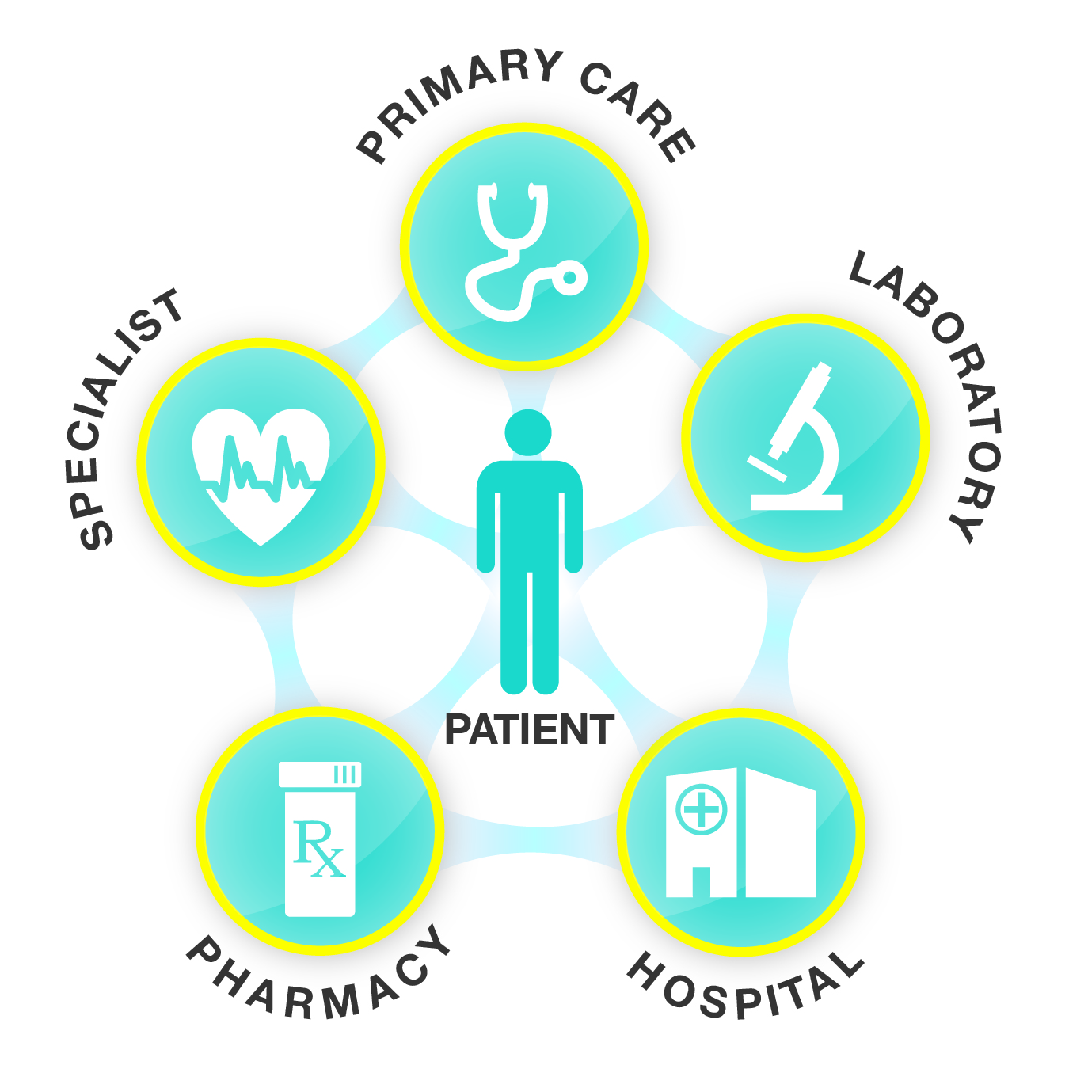

**What Health Information Exchange Means for**

**Policymakers**

Higher-quality, more efficient health care through health information exchange helps to:

* Reduce medical errors and improve appropriateness of treatments delivered;
* Create a more cost-effective health care system with less waste.

**What Health Information Exchange Means for**

**Health Care Providers**

Sharing updated, electronic patient information with other providers enables you to:

* Access and confidentially share patients’ vital medical history, no matter where your patients are receiving care—specialists’ offices, labs or emergency rooms;
* Provide safer, more effective care tailored to your patients’ unique medical needs.