Transferring Records between Providers
HIE Scenario, Workflow and Specifications

Provided By:
The National Learning Consortium (NLC)

Developed By:
Office of the National Coordinator for Health IT (ONC)
Office of Science and Technology (OST)
The material in this document was developed by Regional Extension Center staff in the performance of technical support and EHR implementation. The information in this document is not intended to serve as legal advice nor should it substitute for legal counsel. Users are encouraged to seek additional detailed technical guidance to supplement the information contained within. The REC staff developed these materials based on the technology and law that were in place at the time this document was developed. Therefore, advances in technology and/or changes to the law subsequent to that date may not have been incorporated into this material.
May 31, 2012 • Version 1.0

National Learning Consortium
The National Learning Consortium (NLC) is a virtual and evolving body of knowledge and tools designed to support healthcare providers and health IT professionals working towards the implementation, adoption and meaningful use of certified EHR systems.
The NLC represents the collective EHR implementation experiences and knowledge gained directly from the field of ONC’s outreach programs (REC, Beacon, State HIE) and through the Health Information Technology Research Center (HITRC) Communities of Practice (CoPs).
The following resource is an example of a tool used in the field today that is recommended by “boots-on-the-ground” professionals for use by others who have made the commitment to implement or upgrade to certified EHR systems.
Description & Instructions
This resource is intended to aid providers and health IT implementers in understanding health information exchange (HIE) solutions related to the Meaningful Use Menu Measure 8 – Transition of Care.
This scenario provides a practical example of how the contents of the Nationwide Health Information Network (NwHIN) portfolio can be used to achieve meaningful electronic exchange of health information. This is part of a series of HIE scenarios intended to provide a straightforward view into the standards, services and policies behind HIE solutions.
Each document in the HIE scenarios series describes an everyday situation where patient care is improved through information exchange between health care professionals.
The scenario is presented through a narrative description of events and a corresponding graphic, followed by a detailed description of the workflow steps involved. The resource concludes with an inventory of the key specifications and resources necessary to implement the information exchange described.
Other scenarios and their related specifications can be found on the S&I Framework Repository at: http://www.siframework.org/. Additional questions may be sent via email to: info@siframework.org.

Table of Contents
1 Transferring Records between Providers 1
1.1 Common workflow steps for this scenario 2
1.2 NwHIN 1.0 specifications and resources recommended for this scenario 2

Transferring Records between Providers
A physician transfers a patient's medical records to a different provider practice, and the patient’s new provider receives the records: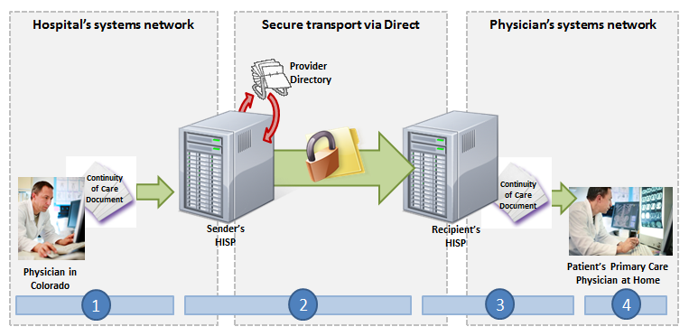
A patient is referred to a dermatologist practice by his primary care physician. Because the patient’s conditions require care from a dermatological specialist but are not unique enough to necessitate a visit from a particular type of dermatologist, his primary care physician feels comfortable referring him to a general dermatology practice. The primary care physician transfers his patient’s records to the dermatology practice office via a Direct group practice address (one that is not specific to an individual physician). The dermatology practice coordinator schedules the patient with one of their specialists and the records are forwarded.

Meaningful Use Stage 1 Objectives related to transitions of care: The EP, eligible hospital or CAH who transitions or refers their patient to another setting of care or provider of care should provide a summary care record for each transition of care or referral. (Meaningful Use Menu Set Measure 8 for EPs, Meaningful Use Menu Set Measure 7 for EH/CAHs)

Common workflow steps for this scenario
- The physician extracts the medical records for the patient from his EHR, which has been properly formatted according to the HL7 CDA Release 2 CCD standard using Logistical Observation Identifiers names and Codes (LOINC) 2.38, RxNorm, and Systemized Nomenclature of Medical--Clinical Terms (SNOMED-CT). He then authors a Direct message and attaches the record. In order to select the patient’s new dermatology practice as the recipient, the physician accesses a search dialogue in the Health Information Service Provider’s (HISP) user interface, which queries a Provider Directory (adhering to the Certificate Discovery for Direct specification) for the right Direct group practice address.
- When the physician sends the message, it passes through his office’s HISP, a contracted brokering agent responsible for the management of security and transport for directed exchange. As it passes through the HISP, the message is encrypted using the x.509 Certificate associated with the physician, and is delivered to the dermatology practice’s Direct group address in accordance with the Applicability Statement for Secure Health Transport.
- The dermatology practice’s HISP decrypts the message and sends it to the practice coordinator who identifies the appropriate specialist within the practice for the patient, schedules the appointment, and uploads the information to the patient’s electronic medical record as an attachment, then forwards the record to the specialist before the patient’s appointment.
- The specialist reviews the information in the attachment and determines which data are appropriate for uploading into the patient’s medical record as structured data. The attachment remains associated with the record.

NwHIN 1.0 specifications and resources recommended for this scenario
Specifications | Resources
Content Structure  Guidance that specifies how to structure health information to ensure proper exchange | - HL7 CDA Release 2 CCD
Vocabulary & Code Sets  Specifications that identify common naming conventions necessary for proper health information exchange | - ICD-9-CM  - Logistical Observation Identifiers names and Codes (LOINC) 2.38  - RxNorm  - Systematized Nomenclature of Medicine--Clinical Terms (SNOMED-CT)
Transport and Security  Mechanisms and processes that safely exchange health information over the Internet | - Certificate Discovery using Domain Name System (DNS) and Lightweight Directory Access Protocol (LDAP)  - Applicability Statement for Secure Health Transport  - x.509 for Certificates

