Sending Patient Follow-Up Care Instructions
HIE Scenario, Workflow and Specifications

Provided By:
The National Learning Consortium (NLC)

Developed By:
Office of the National Coordinator for Health IT (ONC)
Office of Science and Technology (OST)
The material in this document was developed by Regional Extension Center staff in the performance of technical support and EHR implementation. The information in this document is not intended to serve as legal advice nor should it substitute for legal counsel. Users are encouraged to seek additional detailed technical guidance to supplement the information contained within. The REC staff developed these materials based on the technology and law that were in place at the time this document was developed. Therefore, advances in technology and/or changes to the law subsequent to that date may not have been incorporated into this material.
May 31, 2012 • Version 1.0

National Learning Consortium
The National Learning Consortium (NLC) is a virtual and evolving body of knowledge and tools designed to support healthcare providers and health IT professionals working towards the implementation, adoption and meaningful use of certified EHR systems.
The NLC represents the collective EHR implementation experiences and knowledge gained directly from the field of ONC’s outreach programs (REC, Beacon, State HIE) and through the Health Information Technology Research Center (HITRC) Communities of Practice (CoPs).
The following resource is an example of a tool used in the field today that is recommended by “boots-on-the-ground” professionals for use by others who have made the commitment to implement or upgrade to certified EHR systems.
Description & Instructions
This resource is intended to aid providers and health IT implementers in understanding health information exchange (HIE) solutions related to the Meaningful Use Menu Measure 5 – Patient Electronic Acces.
This scenario provides a practical example of how the contents of the Nationwide Health Information Network (NwHIN) portfolio can be used to achieve meaningful electronic exchange of health information. This is part of a series of HIE scenarios intended to provide a straightforward view into the standards, services and policies behind HIE solutions.
Each document in the HIE scenarios series describes an everyday situation where patient care is improved through information exchange between health care professionals.
The scenario is presented through a narrative description of events and a corresponding graphic, followed by a detailed description of the workflow steps involved. The resource concludes with an inventory of the key specifications and resources necessary to implement the information exchange described.
Other scenarios and their related specifications can be found on the S&I Framework Repository at: http://www.siframework.org/. Additional questions may be sent via email to: info@siframework.org.

Table of Contents
1 Sending a Patient Follow-up Care Instructions 1
1.1 Common workflow steps for this scenario 2
1.2 NwHIN 1.0 specifications and resources recommended for this scenario 2

Sending a Patient Follow-up Care Instructions
A rehabilitation patient accesses her follow-up instructions via a patient portal: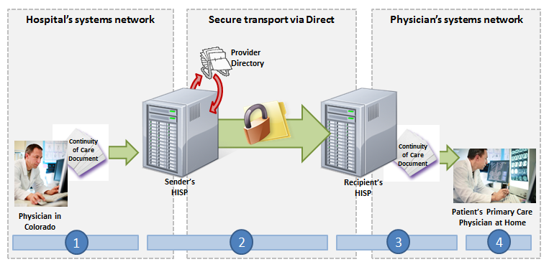
A patient is seen by an orthopedic surgeon at her local hospital and undergoes knee surgery. As part of registering for the hospital’s Patient Portal, the patient is issued a Direct address at the hospital, which she can access from the Patient Portal.
While undergoing rehabilitation from the surgery, she regularly sees a physical therapist at a local outpatient clinic. Instead of sending the patient home with follow-up care instructions on printed paper, the physical therapist sends these documents to her Direct address (provided by the local hospital). The Patient Portal sends a notification email to the patient’s personal email address, indicating that a new secure message has arrived at her Direct address. The patient logs onto the Patient Portal, from which she can retrieve the new Direct message, and view and download the follow-up care instructions.

Meaningful Use Stage 1 Objectives related to delivery of health information to patients: Provide patients with timely electronic access to their health information (including lab results, problem list, medication lists, and allergies) within four business days of the information being available to the EP (Meaningful Use Menu Set Measure 5 for EPs)

Common workflow steps for this scenario
- The physical therapist uses his Direct account to author a message to the patient. He specifies the Direct address the patient provided as the “recipient” for the message, and attaches the follow-up care instructions.
- When the physical therapist sends the message, it passes through the physical therapist’s Health Information Service Provider (HISP), a contracted brokering agent responsible for the management of security and transport for directed exchange. As it passes through the HISP, the message is encrypted using the x.509 Certificate associated with the patient’s Direct address, and delivered to the patient’s Direct address at the local hospital in accordance with the Applicability Statement for Secure Health Transport
- When the message is received at the patient’s Direct address by the hospital’s HISP, an automated email notification is sent from the patient portal to the patient’s personal, non-Direct email address alerting her of the new secure message that awaits on the Patient Portal.
- When the patient logs into the Patient Portal, she accesses the content in her Direct inbox, and downloads the follow-up care instructions that were sent by the physical therapist.

NwHIN 1.0 specifications and resources recommended for this scenario
Specifications | Resources
Transport and Security  Mechanisms and processes that safely exchange health information over the Internet | - Applicability Statement for Secure Health Transport  - x.509 for Certificates

