

National Health Information Network (NHIN)
Operational Infrastructure Architecture Document
Author: Kevin Puscas
Version: .9

Office of the National Coordinator

NHIN Operational Infrastructure Architecture

Introduction
The Nationwide Health Information Network (NHIN) is part of a larger Health IT strategy being enacted by the Health and Human Services Administration. The NHIN is intended to provide a secure, nationwide, interoperable health information infrastructure that will connect providers, consumers, and others involved in supporting health and healthcare. In order to support these goals an architecture and operational infrastructure must be established. This document describes the requirements that drive this infrastructure, how the infrastructure fits into the larger NHIN architecture, and the specific implementation architecture of the infrastructure.

NHIN Architecture Drivers and Principles
The business needs of the ONC provide the basis for deriving a set of architectural drivers. These drivers define the requirements and features that the NHIN architecture must support. The following are the drivers for NHIN architecture.

- Ability to find and retrieve health information between participating NHIE organizations
- Support of harmonized standards, which have been developed by voluntary consensus standards bodies and adopted by the ONC for exchange of health information
- Ability to match patients to their data without the establishment of a national patient identifier
- Support of a common trust agreement that establishes the obligations and assurances to which all NHIN participants agree
- Support of a secure exchange of information between participants
- Ability to support consumer preferences regarding the exchange of their information, including the ability to choose not to participate; and
- Flexibility to support a diverse set of participating organizations.

Based on these drivers a set of guiding principles are defined that help steer the overall architecture for the NHIN.

- Adopt Industry Proven Approaches for Secure Exchange of Information
- Platform Neutral, Standards Based, and Specification Driven
- Highly Distributed and De-Centralized Architecture with a high degree of local autonomy

NHIN Architecture
The NHIN Architecture is designed with aforementioned architectural principles in mind. This architecture can be viewed being made up of two elements. The first part is a set of zones, which define the actions, and responsibilities of the NHIN participants. The second part is the architectural components that exist in these zones and execute based on the actions and responsibilities of the zones. This is seen in Figure 1 below.

Figure 1 - NHIN Operational Architecture

NHIN Architectural Zones
The outer-most zone, the NHIE Zone, contains the geographically distributed participating NHIE systems. Within this zone the NHIE are governed by appropriate local rules, regulations and policies. These NHIEs become inter-connected and interoperable “nodes”, plugged into the NHIN Security Zone. This zone defines rules, specifications, and interfaces that the NHIE nodes must support for secure exchange of information. Within this zone exist the individual NHIE NHIN Gateways that implement the NHIN specified mechanisms required for interoperability. Supporting these NHIN Gateways is the NHIN Operational Infrastructure.

NHIN Architectural Components

NHIE Network
This component represents the collection of organizations that exchange information within a NHIE. These can be hospital ERH systems, Laboratories, PHRs, … Security within the NHIE Network is managed by the constructs of the individual NHIE.

The NHIN Gateway
The NHIN Gateway component is a NHIE’s implementation of the NHIN specified web service interfaces. These web service interfaces communicate over HTTPS secured using Public Key Infrastructure supported by the NHIN Operational Infrastructure.

NHIN Security Zone
The NHIN Security Zone represents secured virtual environment that exists between NHIE gateways. This environment is the implementation of the basic principles behind security on the NHIN.
- The integrity of the information passed is assured for each and every transaction across the NHIN;
- Any information passed across the NHIN can only be understood by participating NHIN organizations and;
- Members of the NHIN have to have reasonable assurance that other participating members will honor service commitments related to security operations.

The primary technical mechanism used to support these principles is the use of a standardized managed Public Key Infrastructure. The infrastructure provides for the governed allocation and management of public key certificates to NHIN participants.

NHIN Operational Infrastructure
These represent the common components needed to support the NHIN participants in conducting distributed, secure communications between NHIE gateways. This Infrastructure consists of a Service Registry, Security Infrastructure, and Operational Availability Monitoring.

Operational Infrastructure Components

Infrastructure System | System Description
- The Services Registry will store meta-data about the NHIN Gateway web services supported by each NHIN participating organization.
- Based on Universal Description Discovery and Integration Registry (UDDI) v3 specification the services registry software will be provided by Hewlett-Packard’s Systinet Foundation Registry product.
- The Services Registry will be hosted in a contracted secured commercial data center provided by ServerVault.
- Runtime system-to-system access to the Services Registry database of meta-data will only be available to other NHIN participants through PKI secured interfaces.
- The primary component of the Security Infrastructure is the Managed PKI (mPKI) Service.
- This will be implemented as a contract to a commercial service provider who will host the required systems needed to support the issuance and revocation of PKI certifications.
- Issuance and revocation of security certificates will be performed by the NHIN program team as directed by the NHIN Governance bodies

 | The Operational Availability Monitoring system is intended to provide availability status information about individual NHIN Gateways.

Operational Infrastructure Implementation

Security Infrastructure

Managed PKI Provided:
NHIN will use PKI technologies to encrypt messages sent between participating entities. Only NHIN participants will have access to the certificates allowing for encryption/decryption of messages sent over the network. NHIN will contract with a commercial vender as the trusted third party to create and manage the certificate process. Digital certificates will insure that message integrity and confidentiality.

Distribution of keys to NHIN participants occurs only after required legal and policy requirements have been met. NHIN participants will request a certificate from the mPKI vendor web site (which is NHIN branded). The certificate will only be issued after a NHIN certificate administrator approves the request. If required, the NHIN administrator(s) can revoke a certificate using the vendor mPKI interface. Communicating parties must both have valid certificates with a NHIN intermediate, this insures that the messages were sent from valid NHIN participants.

The mPKI vendor also will provide a test mPKI environment that will be used to issue pilot certificates for QA purposes. The pilot environment functions like the production mPKI but the certificates that are issued do not have the NHIN intermediate and therefore cannot be used in a production capacity.
The process to request certificates is outlined below. The process flow is the same for pilot (test) or production environments. It should be noted that the pilot and production environments are totally separate mPKI instances. An example of this process can be seen below.

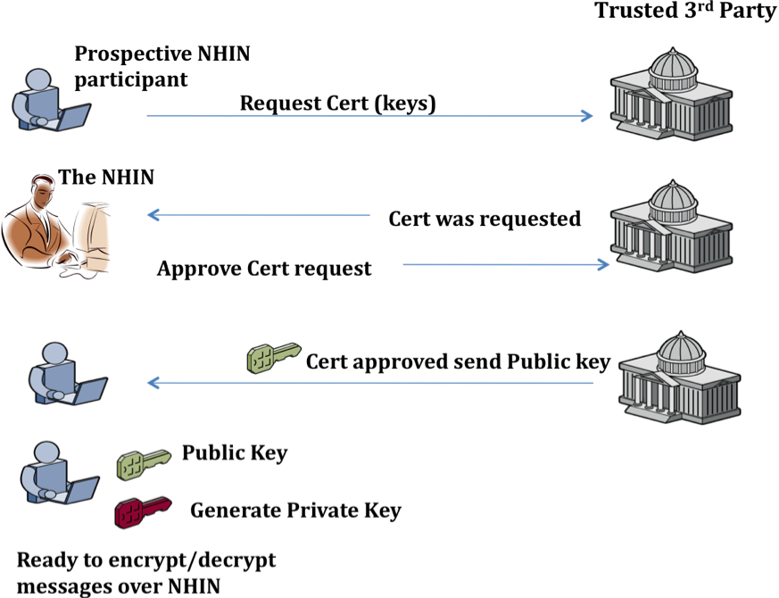

Figure 2 - Certificate Request Process

Non-Technical Security Controls

In addition to the technical controls discussed above the NHIN has a very strict on boarding process that includes testing certifications, technical guidelines for participants, and legal agreements -- DURSA (Data Use and Reciprocal Support Agreement). This process insures that participants are well known to the NHIN and the other participants.

Service Registry
Given the central role of the NHIN Services Registry within the NHIN, this production system will be highly available, secure and support replication for redundancy. In addition to the production environment an environment will be created to support NHIN Certification Testing as well as a Staging environment for supporting upgrades and maintenance. Figure 3 depicts the UDDI software stack and deployment topology that is planned for this installation.

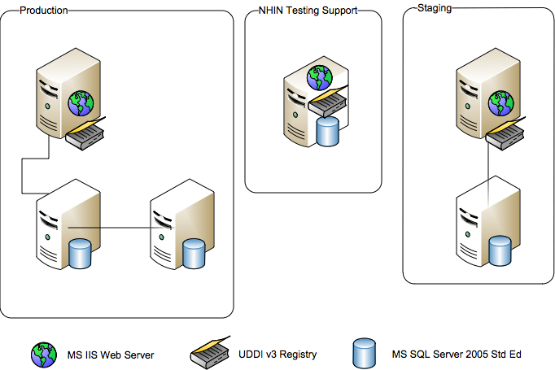

Figure 3 - NHIN Services Registry Implementation Environment

The NHIN Service Registry is designed to be highly scalable and redundant based on a Master/Slave replication model that is part of the UDDI v3 specifications. This model is similar to that used by the Domain Name Services (DNS) infrastructure that is part of the backbone of the Internet. All new entries or updates first occur in the master NHIN Service Registry. This is then propagated to all slave registries. NHIE Nodes can query whichever registry is most appropriate and likewise can subscribe to updates to those registries. The NHIN Services Registry architecture therefore allows updates to not only flow to other registries but to the NHIN participants as well. This can be seen in figure X below.

Figure 4 - Distributed Services Registry Topology

ServerVault as the hosting provider for HP Systinet UDDI

ServerVault is the vendor chosen to provide the secure facilities to host the UDDI registry. ServerVault will provide the following services:

- Facilities management.
- Network access.
- Systems monitoring and help desk support.
- Systems management for the hardware, operating system software, patch management, etc.
- Hardware and software to run NHIN UDDI application. The technical environment is as follows:
- Operating System – MS Server 2003 64 bit.
- RDBMS – MS SQL Server 2005 Standard Edition.
- Web Server IIS 7.0

ServerVault was chosen as a hosting provider because of their deep experience in providing off site systems hosting for numerous government agencies – DoD, VA, SEC, Department of Commerce. ServerVault is very familiar with federal government law, policies, and procedures and has been through the C&A/ATO process numerous times.

Application Software –HP Systinet UDDI Registry. Systinet is the recognized leader in the UDDI registry space. “As a result, the Systinet registry is way ahead of the competition in terms of business-level application functionality. The Systinet registry defines the bar by which all other registries are measured.”

The UDDI registry software that will be installed in the ServerVault environment will be HP Systinet Registry version 6.64. The registry will contain meta-data related to the business services each NHIN participant supports. There is no personally identifiable information in the repository. Each participant will have read only access to the data in the registry. Registry access will be limited to only NHIN participants and controlled via CA certificates. The Systinet software and the underlying database will be supported by NHIN system administrators. See Appendix A for diagrams of the complete NHIN Services Registry implementation topology.

Operational Availability Monitoring
The implementation of the Operational Availability Monitoring system is to be determined based on results of elicitation of program requirements for the system.

Operational Infrastructure Security Plan

In order to establish the NHIN Operational Infrastructure the NHIN Program intends to submit for approval to the HHS CSO office information necessary to receive Certification and Accreditation (C&A) and Authority to Operate (ATO) for the NHIN infrastructure and services. The Security Plan will include four main areas:

- Managed PKI provided by a commercial certificate authority.
- ServerVault as the hosting provider for the UDDI.
- Operational Availability Monitoring; this will be added to the security plan as an addendum when scheduling permits.
- Non-technical Security Controls - DURSA (data use and reciprocal support agreements) the legal agreement between participants plus testing controls, and a strict on boarding procedure is also used to protect HIE.

One C&A and ATO is being created for all NHIN infrastructure components providing a coherent and complete security picture of the entire system.

APPENDIX A – ServerVault Network Topology
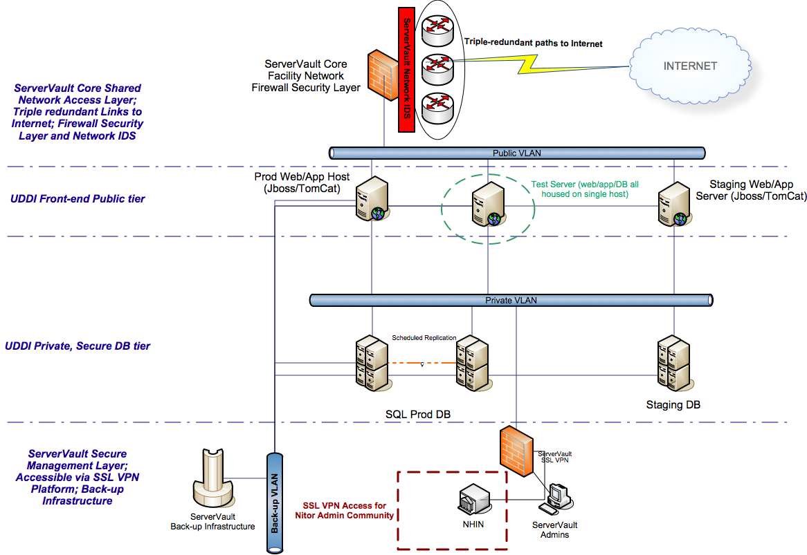

http://uddi.org/pubs/uddi_v3.htm
http://www.servervault.com/main.shtml
“Registry and SOA Governance Market Landscape” by Anne Thomas Manes The Burton Group January 2008; page 8.

