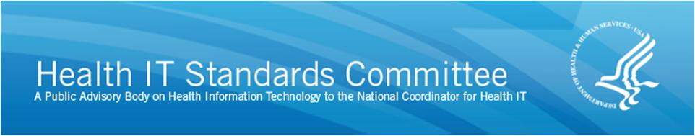

AGENDA

Transport and Security Standards Workgroup
Tuesday, April 21, 2015; 3:00 p.m. – 4:30 p.m. ET

3:00 p.m. Call to Order/Roll Call
— Michelle Consolazio, Office of the National Coordinator

Meeting Objective: NPRM Comments

3:05 p.m. Review of NPRM Comments from April 8th Meeting
- Health IT Module Certification Requirements: Privacy & Security
  - Assignment: John Hummel
- End-User Device Encryption
  - Assignment: Aaron Miri
- Automatic Access Time-Out and Integrity
  - Lisa Gallagher, Co-Chair

3:35 p.m. Workgroup Discussion: NPRM Comments
- C-CDA Data Provenance
- Auditable Events and Tamper-Resistance (time permitting)

4:25 p.m. Public Comment

4:30 p.m. Adjourn

