### Table of Contents

Table of Contents 1

Incentive, Alignment, and Business Practices 2

Timing 4

Workflow, Knowledge, Administrative Overhead 5

Governance 8

Development 10

Standards 11

Privacy and Security 13

## Incentive, Alignment, and Business Practices

Conceptual Model:

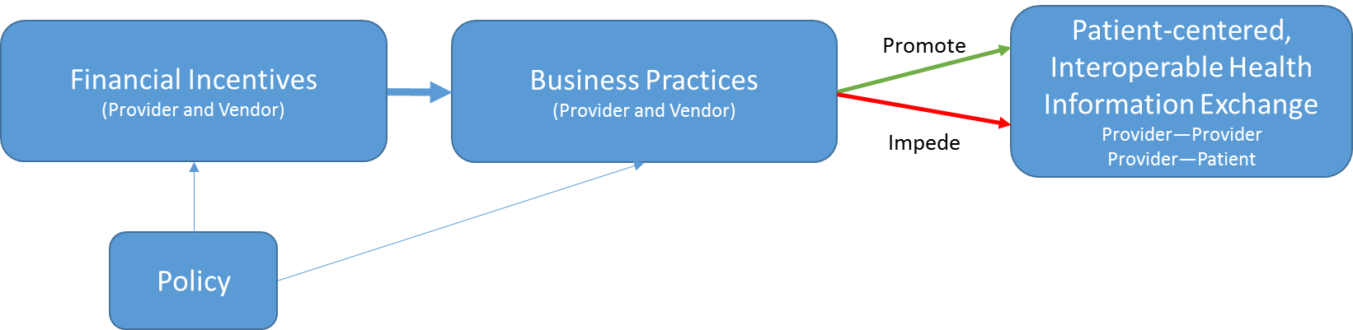

1. Policy Alignment, leading to changes in business practices with some exceptions:
   1. **Payment reform** creates financial incentives to share information across provider organizations, leading to changes in business practices that impeded interoperability (either through explicit decisions not to enable it when given the opportunity, or implicit decisions not to invest in it).
      1. Exceptions
         1. However, collective action is required (i.e., a single ACO cannot compel all other provider organizations to share data), and not all stakeholders have new financial incentives, or are reacting to them by deciding to invest in HIE capabilities
         2. However, the HIE efforts in many markets to which ACOs are turning are facing challenges with sustainability, and they don’t exist in all markets (i.e., HIE infrastructure to support ACOs isn’t robust)
         3. However, there is a lack of consensus on the key quality measures and redundant reporting requirements (*which results in a lack of ability to identify focal types of data for which there are aligned incentives for sharing)*
   2. **Meaningful Use** creates financial incentives to meet criteria, which require information sharing with patients (VDT) and other providers (TOC).
      1. Exceptions
         1. However, because MU is targeted at provider organizations, this results in multiple patient portals and fragmented information;
         2. However, even willing providers are finding it hard to identify who is ready to receive SCRs, particularly in rural communities (and hard because LTPAC and mental health were not part of MU and therefore less likely to be ready trading partners); also difficulty finding Direct addresses of potential trading partners
         3. However, timelines are unaligned or misaligned (MU and more broadly);
         4. However, MU is currently pushing “more data” versus ensuring data is useful
   3. Recommendations from HELP panelists:
      1. Focus on certification as key lever, and public API-based architecture as goal
      2. Use CMS to drive adoption of standards or business practices that facilitate re-use and exchange of data (specifically in the case of patient assessments in LTPAC, increase in availability of ADT feeds, and electronic availability/push of discharge summaries)
      3. Harmonize quality/outcome measures across programs (public and private); allow deeming on process measures where nesting occurs.
      4. Customize incentives based on experience w/ advanced payment models: for advanced organizations, highly-focused supplements to capitated payments for more use of HIE, and for less advanced organizations (i.e., more FFS), highly focused payments to support HIE-enabled cognitive activities (e.g., higher E&M coding for HIE enabled reconciliation)
      5. New accountable care models that more heavily feature LTPAC, behavioral health, and home health as way to motivate investment in HIE capabilities
      6. Pilots for electronic shared care planning tools including HIE (to learn about how to ensure shared data is useful, across the care continuum)
2. Financial Alignment:
   1. **Perceived Economic Disadvantage to Sharing Data:** Providers and EHR vendors perceive more certain financial benefit from limiting access to data, as opposed to sharing it, and instantiate this in business practices (e.g., agreements and contracts that limit sharing)
      1. For providers, this manifests as business decisions and business practices in which they fail to invest in HIE capabilities, or do so selectively
      2. For EHR vendors, this manifests as business practices that result in providers, HIE efforts, and others facing high fees for interoperability, and vendors working to hide alternative, lower cost options (i.e., taking advantage of an information asymmetry).
   2. Recommendations from Senate HELP panelists:
      1. For providers:
         1. Per above, speed the pace of transition from FFS to accountable care, and do so at the market level such that all trading partners in a given region are interested in sharing information at the same time
         2. CMS-led public reporting of degree to which hospitals and provider orgs are “appropriately sharing information” and/or HIE-sensitive outcome measures (which may be easier to measure).
         3. Raise TOC threshold to drive information sharing beyond preferred trading partners. Note: This is being proposed but may have the unintended consequence of more advanced organizations doing the heavy lift for others (with or without their cooperation).
         4. Require CQM measures derived from a comprehensive record of the care each patient receives, rather than data held by a single provider organization
            1. Healthcare Provider Business Practices

Decades of care have assumed little or no information from other providers. There is very limited experience with incorporating outside information, or even historical info from the same provider organization, in the care process and in decision making.

The experience of the Joint Commission with Medication Reconciliation has demonstrated the difficulties in doing this well regardless of technology.

Initial attempts at incorporating standardized information from other providers (Direct, Care Summaries, Reconciliation, etc.) are showing some technical success but little clinical success and many reported problems of low usability of functionality, too much, little data and not the “right” data, and information at other than the optimal time for its use.

A “network” effect of critical mass adoption is needed for these changes to occur.

Several types of clinical/business process change are needed to use the information now becoming available.

There are examples of success.

* + 1. For vendors:
       1. Similar CMS-led public reporting for vendors and/or more transparency on pricing for interoperability. However the challenge is that contracts are private documents. An alternative may be a voluntary code of conduct with which vendors can comply (and there is evidence on the effectiveness of voluntary compliance from other industries/domains).
       2. Two-stage certification: Initial lab and once in the field (to ensure that interoperability capabilities are deployed/switched on that goes beyond current surveillance activities)
       3. Enhance ONC Certified EHR Technology Surveillance program (that could be tied to transparency by publicly reporting valid complaints), require timelines for vendors to address valid complaints, and shift responsibility away from Accreditation bodies to remove conflict of interest

## Timing

Each federal program has well intentioned objectives, but both the regulatory requirements and timelines are not aligned.  Misaligned timelines can have unintended consequences, which are costly to the industry:

* Prematurely implementing regulatory requirements ahead of development maturity can cause rushed development and implementations, which may adversely affect quality of product, implementation and provider workflow.  Synchrony required for smooth implementation includes:
  + Standards approval and adoption
  + Final rule for required functionality
  + Robust testing tools
  + Certification scripts availability
* Unsynchronized readiness (e.g., due to voluntary or menu requirements) of clinical trading partners inadvertently penalize earlier adopter
* Unsynchronized timelines (e.g., EP vs EH) cause incompatibilities that interfere with interoperability

## Workflow, Knowledge, Administrative Overhead

1. In order to ensure that information about a patient from all sources are properly matched to the right person, a robust person identity-matching system must be created. Strategies to accurately match information with the right person may include a unique health identifier and methods to validate the match. Likewise, unique identification of health professionals and organizations are required for effective care coordination.   
  
2. Effective exchange of health data takes into account the workflow of the recipient. Effective information exchange depends on transmitting and receiving the right information. The relevance of information is more important than the volume of data exchanged.  
  
3. Patients are also a direct beneficiary of effective interoperability; they need a consolidated view of their data, too.   
  
**Certification and Interoperability**

Why is this important?

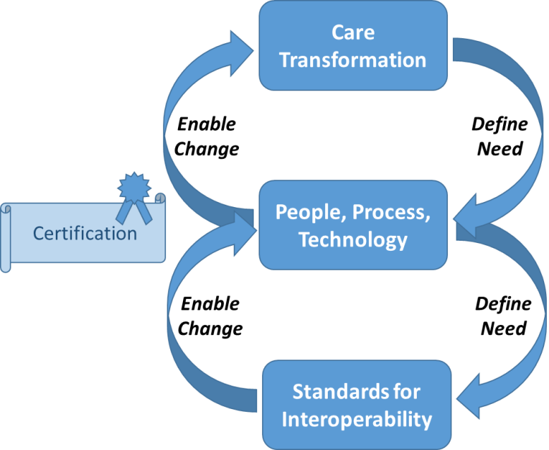

* Standards enable care transformation at scale
* Care Transformation drives need for standards (implement at scale with “commodity” pricing)
* Defined processes further drive standards
* Certification is part of the process of ensuring that technology implements the standards.

**Five Factor Framework for Certification Programs (Recommendation to ONC from Implementation and Certification Workgroup of the Health IT Policy Committee)**

1. Advance a National Priority or Legislative Mandate: Is there a compelling reason, such as a National Quality Strategy Priority, that the proposed ONC certification program would advance?
2. Align with Existing Federal/State Programs: Would the proposed ONC certification program align with federal/state programs?
3. Utilize the existing technology pipeline: Are there industry-developed health IT standards and/or functionalities in existence that would support the proposed ONC certification program?
4. Build on existing stakeholder support: Does stakeholder buy-in exist to support the proposed ONC certification program?
5. Appropriately balance the costs and benefits of a certification program: Is certification the best available option? Considerations should include financial and non-financial costs and benefits. "

**Interoperability Requires an Ecosystem**

Interoperability requires an ecosystem. By its very definition, interoperability, the exchange and use of information, crosses systems, crosses organizations and crosses geography. There is a potentially vast infrastructure or ecosystem of cooperating entities needed for interoperability to occur.

Further, our desire for interoperability is broad and addresses many uses and styles of exchange and connectivity.

**Use Cases**

* Information follows the patient
* Information with the patient (Personal Health Record/Health Record Bank)
* Information at a new setting (planned/unplanned)
* Information for Clinical Decision Support
* Information for Care Coordination
* Information for Public Health Reporting
* Information for Quality Measure calculation & reporting
* Bulk data transfers (for changing EHRs, for research, for other activities) – export/import

**Types of Exchange**

* Document Push
* Document Pull
* Data Element Push
* Data Element Pull
* Transactional Messages
* Documents
* API
* Bulk
* Broadcast (for example, request for patient information across a community of providers)
* Publish/Subscribe (for example, notification of an ED visit to providers/payors/ACOs with an established relationship to that individual)

**Standards**

* Data Elements / Terminology/nomenclature & values
* Data “Statements” (beyond an observation or assertion about a patient, for example, a care plan)
* Data in Context/Metadata
* Data Provenance (as it moves)
* Transport
* Consent (captured, communicated, used to enable exchange, …)
* Governance (clinical, administrative, technical)
* Quality Measures for interop (How do we measure the success of interoperability?)
* Instrumentation to track/measure interop (How might the technology be instrumented to automatically report on its use?)

With more than one type of interoperability/information exchange, there are multiple ecosystems.

What aspects of those ecosystems should be certified?

Needs Hierarchy for Interoperability … What is success? …. What is working?

Ecosystem to enable interoperability

Implementation Heterogeneity

Use Case

People + Process + Technology

Tech as Implemented

Tech as Delivered / Tested

Test Criteria / Test Automation

Standards + Implementation Guides

Link with CQM/eCQM… data

**Certification Process**

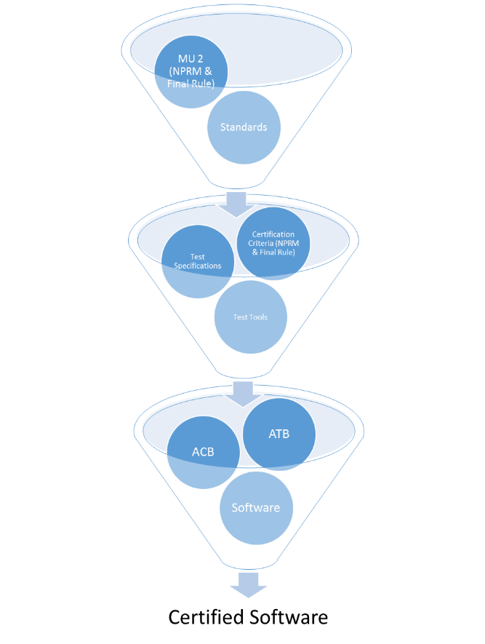

**Certification of WHAT?**

* EHR modules related to MU (current focus)
* Provider health IT needed for info exchange/interop (broader then MU, EP/EH, EHR)
* Eco-system/Infrastructure for Exchange

Certification Process/Timeline / Timing of Certification Components

Iterative improvement / PDSA / Kaizen

Role of ACBs and ATLs

Feedback from the test process

Feedback from the field (on the test process, on the criteria, on the objectives/use cases)

Trends

**Business Drivers/Care Transformation including Technical Innovation**

Use of info from other providers is new

Alignment with other Federal initiatives

## Governance

1. Interoperability has been hampered historically by a lack of incentives and by market fragmentation
   1. Technical, strategic, and financial considerations inhibit practical HIE
   2. Advanced health models are motivating providers to want to share data but integration across EHR systems is still a challenge
2. Governance is required to overcome this collective action problem brought about by market fragmentation
   1. Governance definition: a common understanding among a group of entities about technical, legal, and business alignment to achieve an agreed upon set of goals, and clearly articulated expectations about appropriate behaviors required to achieve those goals
      1. Solve a variety of problems that go beyond just technical infrastructure
      2. May not require government, and indeed, in other most other industries, market-based governance has proven to be more effective and durable over time
      3. Federal and state governments are significant market participants in health care and thus have considerable influence on interoperability and governance through market actions alone
      4. Federal and state governments have many market-reinforcing levers to shape and rapidly accelerate nationwide interoperability, however, alignment and coordination of those levers is an ongoing challenge
   2. TOC and VDT experience in the market has shown that there are two significant challenges that can only be addressed by governance: 1) coordination of trust across entities; and 2) workflow and process innovation to accompany technical innovation
   3. Conventions for transport and content and processes are developing but there is still a lot of variation in the market
   4. The development of market ecosystems takes time, however, especially in the current situation where technology and payment models are both highly dynamic
3. As demand for interoperability has started to grow, driven by Meaningful Use and by the growth in accountable care, governance networks have begun to form that are beginning to solve this collective action problem
   1. Advanced health models recognize importance of practical data-sharing
   2. Networks have up until recently been geographically focused but they are now forming along a number of affinity dimensions (vendor-driven networks, research-driven networks, etc)
   3. Patient-driven governance could become significant in the future as VDT and APIs give patients more visibility into and control over how their data is used
4. If it follows the pattern of other industries, nationwide interoperability will be established by connecting market-based networks according to a common understanding of what is required for nationwide interoperability and which standards/approaches should be used for such requirements
   1. All networks don’t have to be the same, they just have to be able to bridge technical, legal, and business differences to meet the set of common transactions and behaviors that constitute nationwide interoperability
   2. For example, patient-matching, authentication and authorization, format and content conventions, patient permission, etc.
   3. A clear, concise, achievable, and widely-accepted definition of nationwide interoperability is a pre-requisite to achieving nationwide interoperability, and that definition is still evolving. The ONC Interoperability Roadmap provides useful guidance.
5. The market is making rapid progress in this area and the best approach for government at this point is to use the various levers at its disposal to catalyze and motivate market-based accountability and governance for interoperability
   1. Networks like DirectTrust, Care Everywhere, CommonWell, ehealth Exchange, Surescripts, and others are solving these problems among a growing number of providers, however, the need for cross-network bridging is now apparent
   2. Bridging would create nationwide interoperability through a “coordinated architecture”, which loosely couples data-sharing arrangements using standards and approaches based on internet principles and building blocks – eg, a “public API” that defines what should be universally available and under what set of terms
   3. Federal government can play a significant role in motivating market-based governance of nationwide interoperability through: transparency, building core infrastructure, guidance (eg privacy, network bridging standards), convening, incentive alignment (accountable care), operational alignment (market actors)
   4. Top-down regulation should be a last resort used only if nationwide interoperability does not progress according to a clearly defined set of metrics, goals, and timelines, which have not been articulated yet

## Development

**Summary**

Vendors are challenged with the meeting the requirements of meaningful use and other certifications, while remaining committed to pursuing innovations that will increase the use of interoperable data within the workflows of the EHRs in general. In addition, the varying deployment models and definitions/interpretations of meaningful interoperability leave the development community struggling to adapt to various interoperability efforts across the country and globally.

**Key challenges include:**

* **Spirit of the Rule vs. the Rule itself**. Due to the time constraints and pressures to get to MU certification, HIT suppliers often built the interoperability solutions to the “letter of the law” vs. taking a holistic view of the rule and understanding the “why”. Many interoperability workflows could be enabled if the core spirit of the rule was considered.
* **Demanding workflows**. Demand for in depth functionality around importation of interoperable data was not well received by clinical users. While the concept of outside data reconciliation is widely supported, the reality is that physicians and clinical staff do not often perform this workflow in the pre-interop world. Because of this, new workflows have to be introduced, users trained, and process implemented. A typical response from a physician, “This takes too long, can’t I just look at it?”
* **Variance in Networks**. Connecting the interoperable EHR to an existing network /HIE remains a top driver of the cost associated with interoperability. Standards interpretation causes numerous adapters to be implemented, reducing scalability and increasing support costs
* **Complex Standards**. Many of the existing standards are complex and difficult to design around and develop against. Deep technical knowledge of the content specification and the interoperability standards themselves cause lengthy development times and highly specialized resources.
* **Lack of National Infrastructure/Network** Models associated with EDI, ePrescribing and Direct are all examples of networks that have been established that allow the HCO to connect once and instant connectivity with a majority of the stakeholders is realized. “Why is this so hard and complex?” is the typical response when connecting to DSNs.

**Recommendations and future directions**

* Understand the true timetable for development work required for interoperability, including development, testing, certification, system upgrades, implementation, workflow redesign and training across the entire client bases of EHRs
* Certify a core set of functions that speak to the “spirit of the rule”, not just the rule itself
* Insure all sides of the interoperability stakeholders are incented. Transitions of Care rule often had acute vendors sending TOC summaries to LTPAC facilities that have no incentive to use or adopt the technology, causing the acute facilities to purchase direct accounts and workflow tools for these facilities, which, without incentive, saw no value in the workflow.
* Resist from attempting to legislate innovation around how interoperable data could be used. Use in CDS and other innovations will come with the ease of obtaining semantic data and increased incentives for the health care industry to use it.
* Simpler standards (See Josh’s summary). FHIR could enable a new era in interoperability, but still have to tackle all the other barriers.
* Insure Data Content is reflective of need. Need more narrative content to be defined as part of the summary. Missing the patient story.
* Strive for patient centered models that remove organization blocking and complex consent and governance challenges. Having the patient in the middle can solve many of the barriers existing today.

## Standards

**Executive Summary**

Healthcare data standards support active data exchange workflows today, but clinicians and patients face serious challenges on the ground. We need modular standards that can be tailored to high-value healthcare workflows, with modern software development practices and rigorous measurement and testing procedures.

**We see some successes today...**

Under the Meaningful Use Stage 2 incentive program, 2014-certified EHRs enable exchange of clinical data via the Consolidated CDA document format. Two key patterns are: exchange among clinicians ("Transitions of Care") and exchange at a patient's request ("View, Download, Transmit").

**But key challenges include:**

* **An immature ecosystem**. Structured data can be hard to interpret, with relevant details missing or buried in a long, hard-to-navigate document. The same fields are often used in inconsistent ways (though implementations are improving with real-world testing).
* **Awkward workflows**. It can be hard to know which providers are able to receive data, and hard to produce a message that includes relevant clinical context (rather than an auto-generated data dump). Most workflows today require a human in the loop to compose a message or click through a portal. Structured data is not enough, without automatable Application Programming Interfaces.
* **Care coordination**. Coordinating care across clinical settings is especially hard without persistent connections among systems who share responsibility for care (vs one-time data dumps), consistent patient identifiers, and shared strategic commitment to this work.
* **Limited data standards**. Standards necessarily focus on a limited, high-value "common data set". But real-world healthcare data are broad and deep, and the need for interoperability extends to sharing unstructured data and loosely structured data that have not been standardized (and can't readily be).

**Recommendations and future directions**

* We should instrument the Meaningful Use program to measure key outcomes including the degree of data exchange, and the the degree to which exchanged data conform to healthcare standards.
* We should invest in new standards and technology while continuing to make iterative improvements to the technology deployed today.
* ONC and CMS should work to motivate industry-wide adoption of common APIs, with a close focus on emerging standards like FHIR, and a focus on ensuring that vendor products can readily be integrated with third-party applications.
* Standards are needed to obtain authorization for data access, to account for disclosures of data.
* Standards should be developed and extended to address high-value data with greater precision, including patient encounter notifications, lab and prescription notifications, behavioral health data, and social determinants of health.
* Some vendors have introduced open API programs that provide documentation and an online sandbox where developers can build and test applications outside of a live production environment. It is still unclear whether it makes sense to regulate a single API that all systems must implement, vs. promoting a proliferation of vendor-specific APIs.

## Privacy and Security