Conceptual Model:
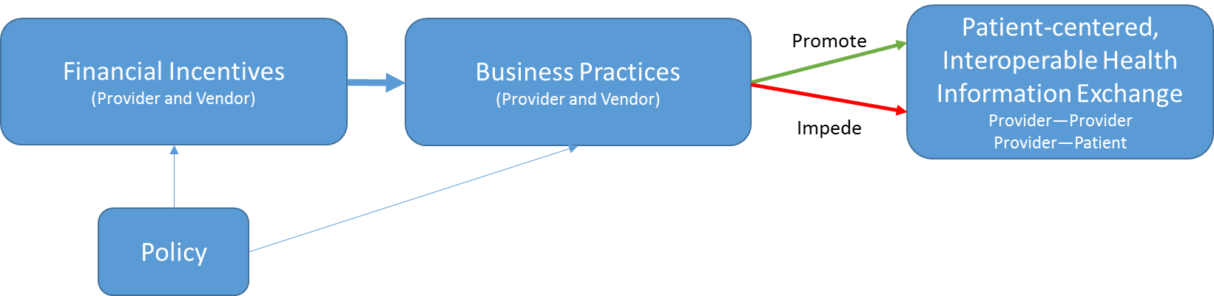

Summary of Excel Document
- Policy Alignment:
  - Payment reform creates financial incentives to share information across provider organizations, leading to changes in business practices that impeded interoperability (either through explicit decisions not to enable it when given the opportunity, or implicit decisions not to invest in it)
    - However, collective action is required (i.e., a single ACO cannot compel all other provider organizations to share data), and not all stakeholders have new financial incentives, or are reacting to them by deciding to invest in HIE capabilities
    - However, the HIE efforts in many markets to which ACOs are turning are facing challenges with sustainability, and they don’t exist in all markets (i.e., HIE infrastructure to support ACOs isn’t robust)
    - However, there is a lack of consensus on the key quality measures and redundant reporting requirements (which results in a lack of ability to identify focal types of data for which there are aligned incentives for sharing)
  - Meaningful Use creates financial incentives to meet criteria, which require information sharing with patients (VDT) and other providers (TOC).
    - However, because MU is targeted at provider organizations, this results in multiple patient portals and fragmented information;
    - However, even willing providers are finding it hard to identify who is ready to receive SCRs, particularly in rural communities (and hard because LTPAC and mental health were not part of MU and therefore less likely to be ready trading partners); also difficulty finding Direct addresses of potential trading partners
    - However, timelines are unaligned or misaligned (MU and more broadly);
    - However, MU is currently pushing “more data” versus ensuring data is useful
  - Recommendations from HELP panelists:
    - Focus on certification as key lever, and public API-based architecture as goal
    - Use CMS to drive adoption of standards or business practices that facilitate re-use and exchange of data (specifically in the case of patient assessments in LTPAC, increase in availability of ADT feeds, and electronic availability/push of discharge summaries)
    - Harmonize quality/outcome measures across programs (public and private); allow deeming on process measures where nesting occurs.
    - Customize incentives based on experience w/ advanced payment models: for advanced organizations, highly-focused supplements to capitated payments for more use of HIE, and for less advanced organizations (i.e., more FFS), highly focused payments to support HIE-enabled cognitive activities (e.g., higher E&M coding for HIE enabled reconciliation)
    - New accountable care models that more heavily feature LTPAC, behavioral health, and home health as way to motivate investment in HIE capabilities
    - Pilots for electronic shared care planning tools including HIE (to learn about how to ensure shared data is useful, across the care continuum)
- Financial Alignment:
  - Perceived Economic Disadvantage to Sharing Data: Providers and EHR vendors perceive more certain financial benefit from limiting access to data, as opposed to sharing it, and instantiate this in business practices (e.g., agreements and contracts that limit sharing)
    - For providers, this manifests as business decisions and business practices in which they fail to invest in HIE capabilities, or do so selectively
    - For EHR vendors, this manifests as business practices that result in providers, HIE efforts, and others facing high fees for interoperability, and vendors working to hide alternative, lower cost options (i.e., taking advantage of an information asymmetry).
  - Recommendations from Senate HELP panelists:
    - For providers:
      - Per above, speed the pace of transition from FFS to accountable care, and do so at the market level such that all trading partners in a given region are interested in sharing information at the same time
      - CMS-led public reporting of degree to which hospitals and provider orgs are “appropriately sharing information” and/or HIE-sensitive outcome measures (which may be easier to measure).
      - Raise TOC threshold to drive information sharing beyond preferred trading partners. Note: This is being proposed but may have the unintended consequence of more advanced organizations doing the heavy lift for others (with or without their cooperation).
      - Require CQM measures derived from a comprehensive record of the care each patient receives, rather than data held by a single provider organization
    - For vendors:
      - Similar CMS-led public reporting for vendors and/or more transparency on pricing for interoperability. However the challenge is that contracts are private documents. An alternative may be a voluntary code of conduct with which vendors can comply (and there is evidence on the effectiveness of voluntary compliance from other industries/domains).
      - Two-stage certification: Initial lab and once in the field (to ensure that interoperability capabilities are deployed/switched on that goes beyond current surveillance activities)
      - Enhance ONC Certified EHR Technology Surveillance program (that could be tied to transparency by publicly reporting valid complaints), require timelines for vendors to address valid complaints, and shift responsibility away from Accreditation bodies to remove conflict of interest

