# Certification and Interoperability

DRAFT – July 28, 2015

## Why is this important?

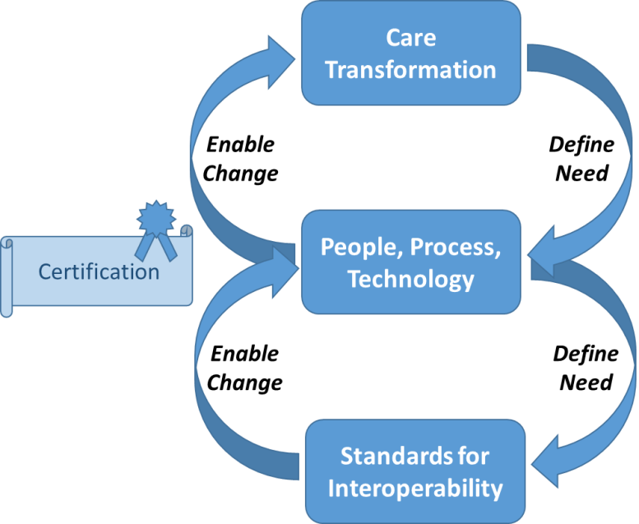

* Standards enable care transformation at scale
* Care Transformation drives need for standards (implement at scale with “commodity” pricing)
* Defined processes further drive standards
* Certification is part of the process of ensuring that technology implements the standards.

## Five Factor Framework for Certification Programs (Recommendation to ONC from Implementation and Certification Workgroup of the Health IT Policy Committee)

1. Advance a National Priority or Legislative Mandate: Is there a compelling reason, such as a National Quality Strategy Priority, that the proposed ONC certification program would advance?
2. Align with Existing Federal/State Programs: Would the proposed ONC certification program align with federal/state programs?
3. Utilize the existing technology pipeline: Are there industry-developed health IT standards and/or functionalities in existence that would support the proposed ONC certification program?
4. Build on existing stakeholder support: Does stakeholder buy-in exist to support the proposed ONC certification program?
5. Appropriately balance the costs and benefits of a certification program: Is certification the best available option? Considerations should include financial and non-financial costs and benefits. "

## Interoperability Requires an Ecosystem

Interoperability requires an ecosystem. By its very definition, interoperability, the exchange and use of information, crosses systems, crosses organizations and crosses geography. There is a potentially vast infrastructure or ecosystem of cooperating entities needed for interoperability to occur.

Further, our desire for interoperability is broad and addresses many uses and styles of exchange and connectivity.

## Use Cases

* Information follows the patient
* Information with the patient (Personal Health Record/Health Record Bank)
* Information at a new setting (planned/unplanned)
* Information for Clinical Decision Support
* Information for Care Coordination
* Information for Public Health Reporting
* Information for Quality Measure calculation & reporting
* Bulk data transfers (for changing EHRs, for research, for other activities) – export/import

## Types of Exchange

* Document Push
* Document Pull
* Data Element Push
* Data Element Pull
* Transactional Messages
* Documents
* API
* Bulk
* Broadcast (for example, request for patient information across a community of providers)
* Publish/Subscribe (for example, notification of an ED visit to providers/payors/ACOs with an established relationship to that individual)

## Standards

* Data Elements / Terminology/nomenclature & values
* Data “Statements” (beyond an observation or assertion about a patient, for example, a care plan)
* Data in Context/Metadata
* Data Provenance (as it moves)
* Transport
* Consent (captured, communicated, used to enable exchange, …)
* Governance (clinical, administrative, technical)
* Quality Measures for interop (How do we measure the success of interoperability?)
* Instrumentation to track/measure interop (How might the technology be instrumented to automatically report on its use?)

With more than one type of interoperability/information exchange, there are multiple ecosystems.

What aspects of those ecosystems should be certified?

Needs Hierarchy for Interoperability … What is success? …. What is working?

Ecosystem to enable interoperability

Implementation Heterogeneity

Use Case

People + Process + Technology

Tech as Implemented

Tech as Delivered / Tested

Test Criteria / Test Automation

Standards + Implementation Guides

Link with CQM/eCQM… data

## Certification Process

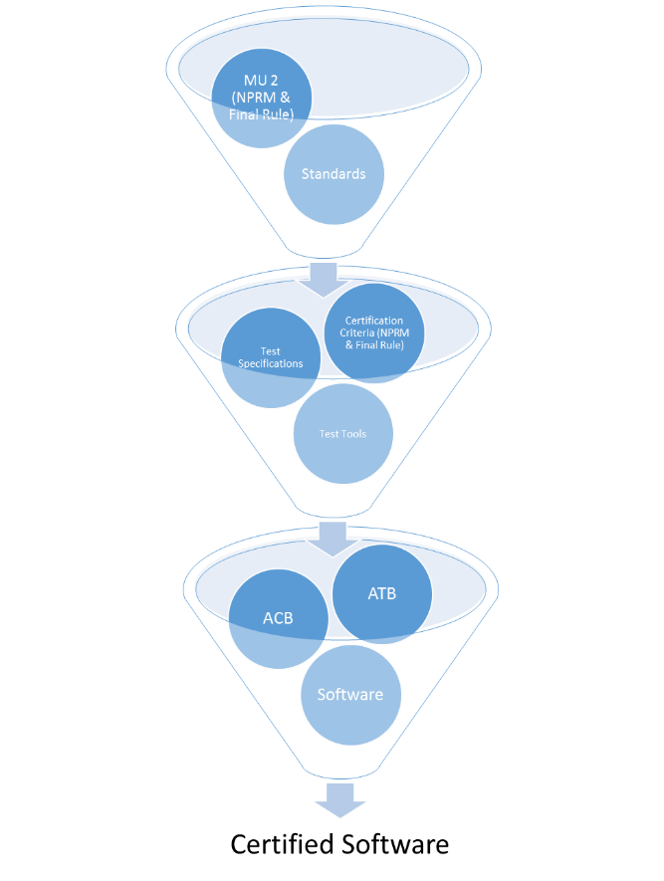

Certification of ***WHAT?***

* EHR modules related to MU (current focus)
* Provider health IT needed for info exchange/interop (broader then MU, EP/EH, EHR)
* Eco-system/Infrastructure for Exchange

Certification Process/Timeline / Timing of Certification Components

Iterative improvement / PDSA / Kaizen

Role of ACBs and ATLs

Feedback from the test process

Feedback from the field (on the test process, on the criteria, on the objectives/use cases)

Trends

## Business Drivers/Care Transformation including Technical Innovation

Use of info from other providers is new

Alignment with other Federal initiatives