Section I- Q

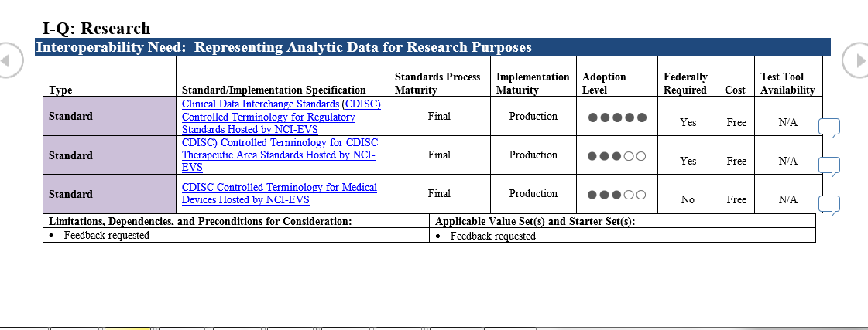

The content for this section is confused, misleading and incomplete.

If we assume the intention was to label them as vocabulary for FDA regulated research, it does not accurately represent what the FDA says.

First URLs for all three rows point to the exact same URL at NCI and there is there is no reason to have three rows because they all point to the same thing. I believe the implementation level refers to the implementation level for the cited CDISC standard not for any specific vocabulary. Has to be the case, otherwise they would all have the same level of adoption. WK suggests including at most the first row. See also recommendations at the end.

Implementers will have difficulty discerning what is to be used for what purposes. I understand that there are CDISC web sites that make this clearer, but they are only available to paid members (not cheap). So the field that says the NCI content if free, is accurate, but very misleading because it may not be possible to figure out what is used for what without paying for a membership

In the past I did have a chance to review the contents of the NCI table (best I can tell there is only one), Many vocabularies for many purposes are included in one table and they are distinguished by an attribute the specifies the kind of vocabulary. It includes lots of laboratory tests, a few radiology and electrophysiology tests, geographic areas and more. The codes all begin with C. I believe these codes are unique to NCI, but had understood that many of the concepts have been mapped to NLM’s UMLS. The lab and other test codes are not LOINC codes.

Secondly this does not line up with what the FDA cite as approved vocabularies. It excludes a many of of coding systems that the FDA specifically calls out and in some case strongly requires. These include, MedDRA ([MedDRA.org](http://www.meddra.org/) ), [Medical Devices Event Problem Codes](http://www.fda.gov/MedicalDevices/Safety/ReportaProblem/EventProblemCodes/default.htm) , the WHO drug codes and LOINC... The laboratory submission specification even includes a specific field for LOINC.

MedDRA is strongly required by the FDA for adverse events and (I believe) preferred for diagnoses, but don’t think the FDA explicitly forbids the use of ICD codes or Snomed. Further the FDA names (and may prefer) the WHO drug codes for identifying drugs. Not one of the code systems mentioned in this paragraph are included in the NCI tables references in I-Q Indeed, MedDRA and WHO drug codes have copyrights that probably precludes their inclusion.

So this table Does NOT represent the coding requirements for FDA regulated submissions. It is very incomplete. Though the codes and concepts listed in the NCI table are allowed for the specific uses they target.

On the other hand the current Label for I-Q is not constrained to FDA regulatory filings. But if it intends to include observational or post marketing surveillance based on medical record content it ignore all of the coding systems used in medical record systems which by necessity includes all of the systems required for billing and for Meaningful use and CMS (plus a few more) namely, CPT, LOINC ICD, SNOMED CT, RxNorm, in some cases NDC and UCUM at least, because those are the coding systems that are available in such systems. MiniSentinal supported by the FDA for post marketing surveillance uses some of these codes and none of the ones listed by NCI, OHDSI uses most of the code listed in the first sentence and it is also be in use by the FDA.

Not sure what to do with this section Either drop it, or divide it into two cases: 1) Codes for FDA regulated research and then include what the FDA actually specified and provide direct links to the FDA web site that specifies them, and 2) research on medical record and billing data and then list all of the relevant coding systems including those listed in the earlier part of this section, and more, i.e. ClinVar, Cosmic, dbSNP etc., etc.