**QUALITY CATEGORY = 50% of Composite Score**

|  |  |
| --- | --- |
| **PQRS in 2016** | **Quality in 2017** |
| 9 CQMs | 6 CQMs  1 of which must be a cross-cutting measure, and  1 of which must be an outcome measure, or  Another high priority measure if outcome is unavailable |
| CQMs must cover at least 3 of the 6 National Quality Strategy Domains | No domain requirement |
| Electronic reporting is the preferred (but not required) submission option. | Electronic reporting is an option which is incentivized by offering a potential bonus point per eCQM up to 5% of total score |
| Certification is required for electronic reporting. | Electronic reporting may take many forms as long as the data is captured using certified EHR technology. |

**ADVANCING CARE INFORMATION (ACI) CATEGORY = 25% of Composite Score**

|  |  |  |
| --- | --- | --- |
| **EHR in 2016** | **ACI in 2017** | **ACI in 2018** |
| 8 objectives | Base: 6 Objectives  No measure specifications changes  No technology changes required | Base: 6 Objectives  No measure specification changes  Must adopt 2015 Edition technology |
| 15 measures required | 8 measures required  3 optional measures | 11 measures required |
| Meet all thresholds in all 15 measures | 1 patient threshold in 8 required measures | 1 patient threshold in 11 required measures |

**CPIA = 15% of Composite Score**

**Resource Use = 10% of Composite Score**

**ACI Measure by Measure Comparison: Base Score in 2017**

|  |  |  |
| --- | --- | --- |
| **For EHR Incentive Programs in 2016 a provider must** | **Comparison** | **For MIPS ACI in 2017 an eligible clinician must** |
| Use CEHRT  2014 Edition | **=**  **=** | Use CEHRT 2014 Edition or 2015 Edition |
| Do a security risk analysis or review | **=** | Do a security risk analysis or review |
| Attest that they are not info blocking |  | Attest that they are not info blocking |
| Implement 5 CDS plus drug-drug, drug-allergy |  | Have the function for implementing CDS including drug-drug, drug-allergy |
| Write 50% of prescriptions electronically |  | Write at least 1 prescription electronically |
| Use CPOE for 60% of medication orders |  | Have the function for CPOE for medication orders |
| Use CPOE for 30% of lab orders |  | Have the function for CPOE for lab orders |
| Use CPOE for 30% of radiology orders |  | Have the function for CPOE for radiology  **Optionally** may include all diagnostic imaging orders |
| Provide Access for 50% of patients to VDT their health information |  | Provide access for at least 1 patient to VDT |
| Provide patient specific education for 10% of patients |  | Provide patient specific education for at least 1 patient |
| Ensure at least 1 patient takes action to VD or T their health information | **=** | Ensure at least 1 patient takes action to VD or T their health information |
| Send or respond to a secure message for at least 1 patient | **=** | Send or respond to a secure message for at least 1 patient |
| Send an electronic summary of care document for 10% of transitions of care |  | Send an electronic summary of care document for at least 1 transition of care |
| Conduct medication reconciliation for at least 50% of transitions and referrals |  | Conduct medication reconciliation for at least 1 transition or referral  **Optionally** may conduct medication, medication allergy and problem list reconciliation |
| Report to at least 2 public health registries |  | Report on immunizations |

**ACI Measure by Measure Comparison: Base Score in 2017**

|  |  |  |
| --- | --- | --- |
| **For MIPS ACI in 2017 an eligible clinician must** | **Comparison** | **For MIPS ACI in 2018 an eligible clinician must** |
| Use CEHRT 2014 Edition or 2015 Edition | **=**  **=** | Use CEHRT 2015 Edition |
| Do a security risk analysis or review |  | Do a security risk analysis or review |
| Attest that they are not info blocking | **=**  **=** | Attest that they are not info blocking |
| Have the function for implementing CDS including drug-drug, drug-allergy | **=** | Have the function for implementing CDS including drug-drug, drug-allergy |
| Write at least 1 prescription electronically |  | Write at least 1 prescription electronically |
| Have the function for CPOE for medication orders | **=** | Have the function for CPOE for medication orders |
| Have the function for CPOE for lab orders | **=** | Have the function for CPOE for lab orders |
| Have the function for CPOE for radiology or diagnostic imaging orders | **=** | Have the function for CPOE for radiology or diagnostic imaging orders |
| Provide access for at least 1 patient to VDT | **IT**  **=** | Provide access for at least 1 patient to VDT and API |
| Provide patient specific education for at least 1 patient | **=** | Provide patient specific education for at least 1 patient |
| Ensure at least 1 patient takes action to VD or T their health information | **=**  **IT** | Ensure at least 1 patient takes action to VD or T or to use an API to access their health information |
| Send or respond to a secure message for at least 1 patient | **=** | Send or respond to a secure message for at least 1 patient |
| **Optional**  Incorporate patient generated health data, or data from a “non-clinical” setting, for at least 1 patient | **=** | **Required**  Incorporate patient generated health data, or data from a “non-clinical” setting, for at least 1 patient |
| Send an electronic summary of care document for at least 1 transition of care |  | Send an electronic summary of care document for at least 1 transition of care |
| **Optional**  Receive directly, request and receive, or query and obtain at least 1 electronic summary of care document for a transition of care received | **=** | **Required**  Receive directly, request and receive, or query and obtain at least 1 electronic summary of care document for a transition of care received |
| Conduct medication reconciliation or clinical information reconciliation for at least 1 transition or referral | **=** | Conduct medication reconciliation or clinical information reconciliation for at least 1 transition or referral |
| Report on immunizations |  | Report on immunizations |

**ACI Performance Score in 2017**

|  |  |  |
| --- | --- | --- |
| **Objective and Measures** |  | **Potential points** |
| **Patient Electronic Access Objective**  Measure 1 – Provide access to VDT for greater than 1 patient  Measure 2 – Provide patient specific education for more than 1 patient | 1 point is awarded for each 10% of the provider’s performance achieved | Measure 1 = 10  Measure 2 = 10  Up to 20 points |
| **Care Coordination through Patient Engagement Objective**  Measure 1 – More than 1 patient takes action to view, download, or transmit their record  Measure 2 – Send or respond to more than 1 secure message  *Optional* Measure 3 – Incorporate patient generated data (or data from a non-clinical setting) for more than 1 patient | Measure 1 = 10  Measure 2 = 10  Optional Measure 3 = 10  Up to 20 or 30 points |
| **Health Information Exchange Objective**  Measure 1 – Send an electronic summary of care document for more than 1 transition or referral  Optional Measure 2 – Receive, request, or query for a summary of care document for more than 1 transition or referral  Measure 3 – Conduct medication reconciliation for more than 1 transition of care or referral or patient never before seen by the provider  *May optionally include medication allergy and problem list reconciliation | Measure 1 = 10  Optional Measure 2 = 10  Measure 3 = 10  Up to 20 or 30 points |
| **Public Health Reporting Objective**  Active engagement to report data to any public health agency or specialized registry beyond immunization reporting | Bonus point is added after base and peformance scores are combined | 1 point added to the total category score |

**ACI Performance Score in 2018**

|  |  |  |
| --- | --- | --- |
| **Objective and Measures** |  | **Potential points** |
| **Patient Electronic Access Objective**  Measure 1 – Provide access to VDT for greater than 1 patient  Measure 2 – Provide patient specific education for more than 1 patient | 1 point is awarded for each 10% of the provider’s performance achieved | Measure 1 = 10  Measure 2 = 10  Up to 20 points |
| **Care Coordination through Patient Engagement Objective**  Measure 1 – More than 1 patient takes action to view, download, or transmit their record  Measure 2 – Send or respond to more than 1 secure message  Measure 3 – Incorporate patient generated data (or data from a non-clinical setting) for more than 1 patient | Measure 1 = 10  Measure 2 = 10  Measure 3 = 10  Up to 30 points |
| **Health Information Exchange Objective**  Measure 1 – Send an electronic summary of care document for more than 1 transition or referral  Optional Measure 2 – Receive, request, or query for a summary of care document for more than 1 transition or referral  Measure 3 – Conduct medication, medication allergy, and problem list reconciliation for more than 1 transition of care or referral or patient never before seen by the provider | Measure 1 = 10  Measure 2 = 10  Measure 3 = 10  Up to 30 points |
| **Public Health Reporting Objective**  Active engagement to report data to any public health agency or specialized registry beyond immunization reporting | Bonus point is added after base and peformance scores are combined | 1 point added to the total category score |

Sample ACI performance Score 81 FR 25222

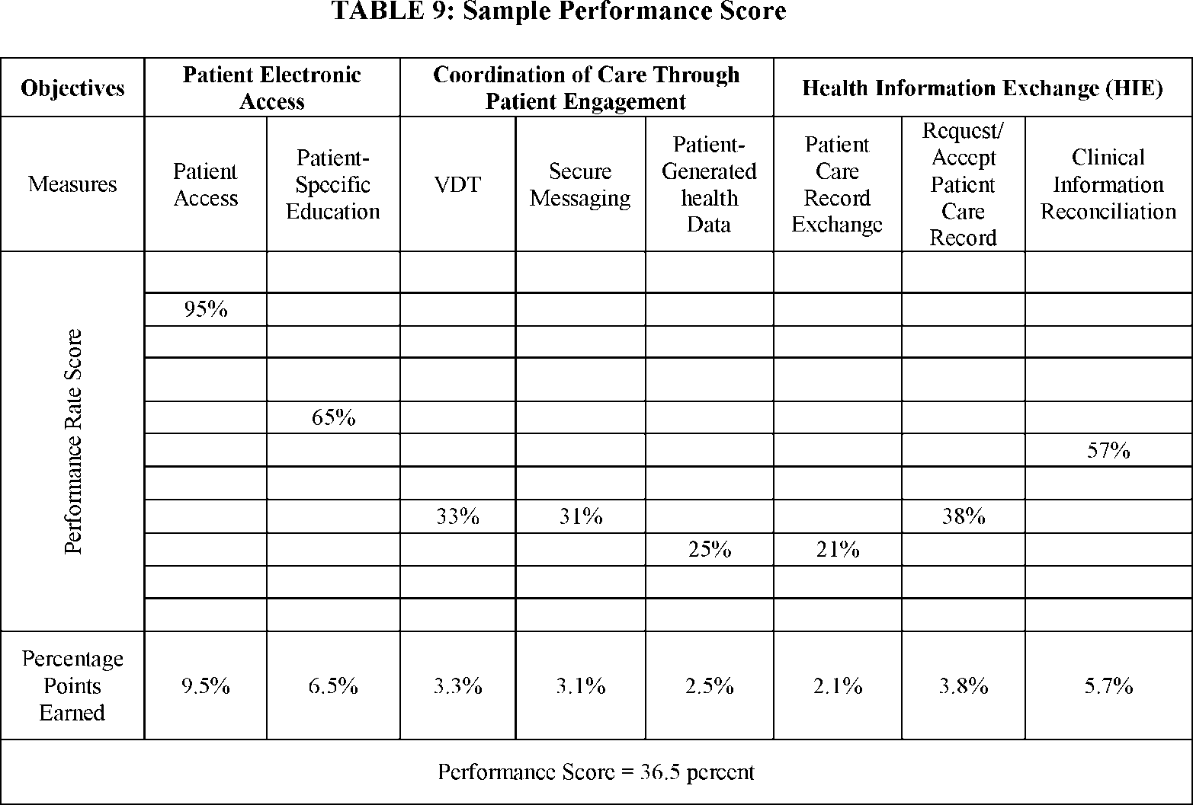

Sample ACI Category Score 81 FR 25228

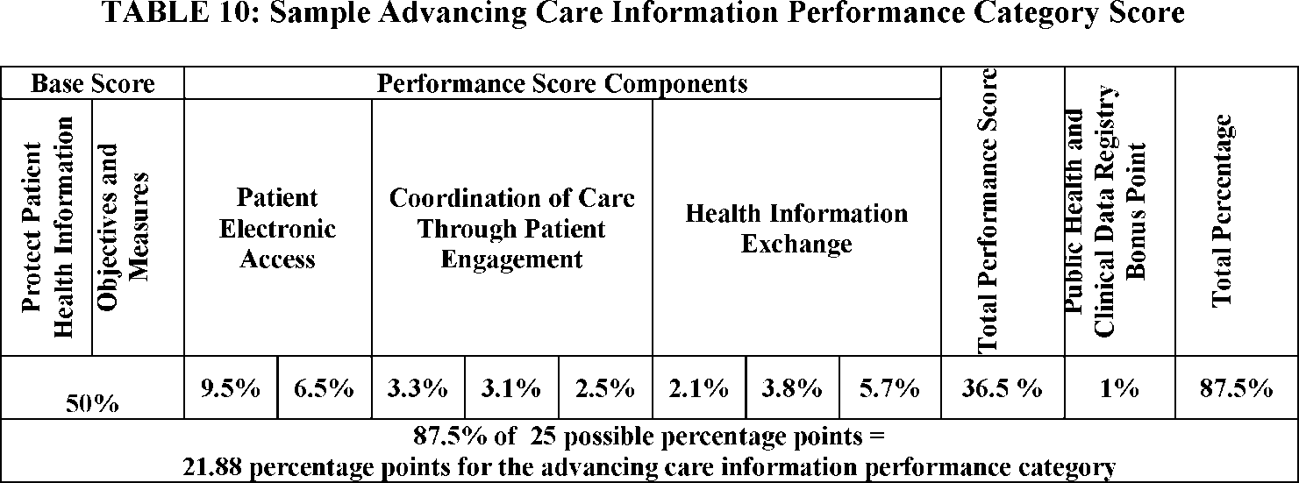

Sample Score for Indiividual and Group Reporting Composite 81 FR 28257

