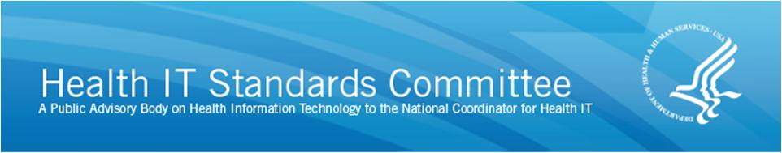

AGENDA

HIT Standards Committee

Content Standards Workgroup
Monday, May 18, 2015, 12:00 p.m. – 1:30 p.m. ET
12:00 p.m. Call to Order/Roll Call
— Michelle Consolazio, Office of the National Coordinator (ONC)

12:05 p.m. Welcome and Opening Remarks
- Andy Wiesenthal, chair
- Rich Elmore, co-chair

12:10 p.m. Group 1 Comment on Certification NPRM
— Kim Nolen, Pfizer

12:35 p.m. Group 2 Comment on Certification NPRM
— Floyd Eisenberg, iParsimony, LLC

12:55 p.m. Group 3 Comment on Certification NPRM
— Calvin Beebe, Mayo Clinic

1:25 p.m. Public Comment

1:30 p.m. Adjourn

