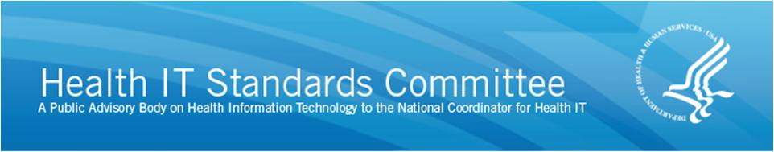

AGENDA

HIT Standards Committee

Content Standards Workgroup
Thursday April 23, 2015, 11:00 a.m. – 12:30 p.m. ET
11:00 a.m. Call to Order/Roll Call
— Michelle Consolazio, Office of the National Coordinator (ONC)

11:05 a.m. Welcome and Opening Remarks
- Andy Wiesenthal, chair
- Rich Elmore, co-chair

11:10 a.m. Debrief on Delivery of HITSC Roadmap Comments to HITSC
- Andy Wiesenthal, chair
- Rich Elmore, co-chair

Comments and Progress to Date on Certification NPRM

11:25 a.m. Group 1
- Kim Nolen, lead

11:45 a.m. Group 2
- Floyd Eisenberg, lead

12:05 p.m. Group 3
- Calvin Beebe, lead
12:25 p.m. Public Comment

12:30 p.m. Adjourn

