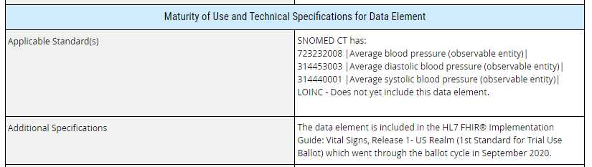

Below are the sections from the original form where the prior information (above) had been added. The content in red font below is the added/edited information for each of the two sections above.

Maturity
Does a vocabulary, terminology, content, or structural standard exist for this data element? (e.g., SNOMED CT, LOINC, RxNorm) * (select one)
X Yes No Unknown
If yes, please cite the applicable standard*:
SNOMED CT has:
723232008 |Average blood pressure (observable entity)|
314453003 |Average diastolic blood pressure (observable entity)|
314440001 |Average systolic blood pressure (observable entity)|
LOINC - Does not yet include this data element.
After the original submission of this form to USCDI in October 2020, LOINC (version 2.69) added a new panel to report the average systolic and diastolic blood pressure measurements taken over a period of time. Therefore,
LOINC has:
96607-7 Blood pressure panel unspecified time mean
96608-5 Systolic blood pressure unspecified time mean
96609-3 Diastolic blood pressure unspecified time mean
If yes, link URL:
Are there additional technical specifications such as an implementation guide (IG) or profile using this data element? (e.g., HL7® FHIR® US Core Implementation Guide v3.1.0 based on FHIR R4)
X Yes No Unknown
If yes, please cite the relevant technical specification(s)*:
The data element is included in the HL7 FHIR® Implementation Guide: Vital Signs, Release 1- US Realm (1st Standard for Trial Use Ballot) which went through the ballot cycle in September 2020.
After this submission was accepted by USCDI in October 2020 as Level 2, the Vital Signs Implementation Guide has completed the ballot process and anticipates reaching STU1 in 2021.

