**Comments_Exchanging Imaging Documents Within an HIE Domain_DICOM**

There are IHE Connectathon testing results for Web-based Image Capture (which uses STOW-RS)

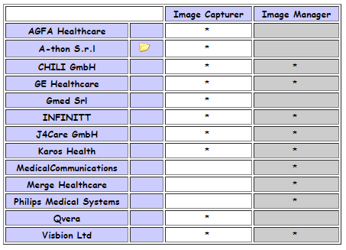

and Web-based Image Access (which uses QIDO-RS and WADO-RS).

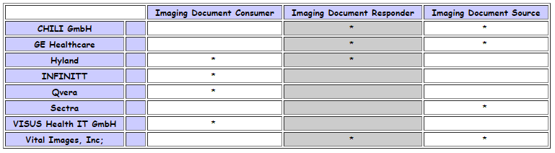

So for DICOMweb, we suggest at least **Medium if not High**, definitely not Low.

**Examples with DICOMweb™  support**

* Agfa
  + Main page: <https://global.agfahealthcare.com/main/miscellaneous/interoperability/dicom_connectivity/>
  + Conformance statement mentioning DICOMweb: <http://www.agfahealthcare.com/global/en/he/library/libraryopen?ID=53821200>
* Sectra
  + Main page: <https://medical.sectra.com/knowledge-center/conformance-statements/>
  + Conformance statement mentioning QIDO/WADO: <https://sectramedical.blob.core.windows.net/uploads/2019/03/pacs-dicom-conformance-statement-21.1.pdf>
* GE
  + Main page: <https://www.gehealthcare.com/products/interoperability/dicom>
  + Conformance statement mentioning DICOMweb: <https://www.gehealthcare.com/-/media/7527e637d6ca478c8f94aca52580e75b.pdf?la=en-us>
* Vital
  + Main page: <https://www.vitalimages.com/customer-success-support-program/compliance-documents/>
  + Conformance statement mentioning DICOMweb: <https://www.vitalimages.com/wp-content/uploads/VLC-10295-A-Vitrea-View-7.5-DICOM-Conformance-Statement_.pdf>
* Orthanc (open source)
  + Main page: <https://www.orthanc-server.com/static.php?page=documentation>
  + Page mentioning DICOMweb support: <https://docs.google.com/spreadsheets/d/e/2PACX-1vSBEymDKGZgskFEFF6yzge5JovGHPK_FIbEnW5a6SWUbPkX06tkoObUHh6T1XQhgj-HqFd0AWSnVFOv/pubhtml?gid=654036639&single=true>
* DCM4CHEE (open source)
  + Main page: <https://dcm4chee-arc-cs.readthedocs.io/en/latest/introduction.html>
  + Page mentioning QIDO/WADO/STOW: <https://dcm4chee-arc-cs.readthedocs.io/en/latest/networking.html>

**Examples with DICOMweb™ support but not in Conformance statement**

* Philips
  + Main page: <https://www.usa.philips.com/healthcare/resources/support-documentation>
  + Mentions DICOMweb here: <https://www.philips.ae/healthcare/product/HCAPP035/dicom-web>
* Merge
  + Main page: <https://www.merge.com/Support/Resources/DICOM-Conformance-Statements.aspx>
  + Mentions DICOMweb AND the latest supplement in DICOMweb on thumbnails: <https://www.merge.com/Solutions/Toolkits/Merge-DICOM-Toolkit.aspx>
* Intelerad
  + Main page: <https://www.intelerad.com/en/resources/regulatory-compliance/>
  + Mentions DICOMweb support here: <https://www.intelerad.com/en/press-releases/intelerad-launches-cosmosone-living-medical-archive/>
* Hyland
  + Main page: <https://www.hyland.com/en/healthcare/conformance-and-standards>
  + Mentions DICOMweb support here: <https://www.hyland.com/en/healthcare/enterprise-imaging/acuo-vendor-neutral-archive>

This list is based on initial research and not complete as there are likely many more.